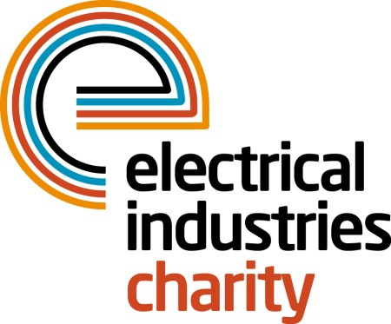
Press Release

20 April 2015

Get the job you want

If your career is at a turning point and you’re not sure where to turn then pick up the phone because the Electrical Industries Charity now offers career advice via their Confidential Helpline.

Working with a leading provider of interactive online career management, the service utilises through a ‘work friend’ portal which has a wealth of audio, video and written material together with tools to help you get more out of the site. The Charity’s Helpline Advisors can also give you access to an individual telephone career coach for three months to help you find a career that suits both your skills and your personality.

Operations Manager, Jill Nadolski says: “There are a number of reasons why people use this service - perhaps you have recently been made redundant or you are returning to work after some time out, or maybe you just need a bit of advice about what opportunities are available to you. Whatever the reason, our Helpline Advisors will put you in touch with someone who can offer confidential and impartial advice about how to manage your career. They understand that today’s jobs place a greater demand on skills and qualifications and they are there to help you make the right decisions about learning and development and the impact they will have on your future career.

“This is a great resource if you do need help with career decisions and planning because it can support you in reviewing your skills and abilities and help to develop new goals. More importantly it can provide the motivation to help you look ahead to a brighter future in a job that you enjoy.”

So if you are looking for information about that important next step in your career or you simply need some advice about completing applications forms and attending interviews; contact the Confidential Helpline on 0800 652 1618.

www.electricalcharity.org

Note to editors
The Electrical Industries Charity is the national charity for the electrical, electronics and energy industries. It aims to look after people from these industries whenever they or their families need help with life’s challenges.

The charitable services are available to anyone who currently works or has worked in the very diverse and often converging industries, such as:
- Electrical contracting and facilities management
- Electrical and electronic manufacturing, wholesale, distribution and retail
- Electrical and mechanical engineering
- Lighting industry
- Generation, distribution and supply of electrical power, including nuclear and renewable energy

For further information about the Electrical Industries Charity please contact Keystone Communications:

Tracey Rushton-Thorpe
Tel: 07753 840386
Email: tracey@keystonecomms.co.uk

