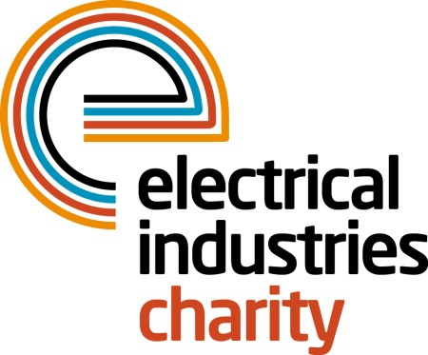
Press Release

27 January 2015

It’s good to talk

A friendly ear is only a phone call away says the Electrical Industries Charity which is urging people to talk about their problems rather than try to cope alone.

Operations Manager, Jill Nadolski says: “The benefits of telephone counselling have been well researched and it is often the preferred option for people who are dealing with emotional problems in their life. Sometime it is easier to talk to a stranger than to relatives or friends and that is why we offer a telephone counselling service which provides a friendly ear when people need it most.”

The telephone counselling service is available through the Confidential Helpline (0800 652 1618) where advisors can arrange for up to five sessions with a qualified telephone counsellor who is accredited by the British Association of Counselling and Psychotherapy.

Jill says: “As a Charity we firmly believe that no-one should have to suffer alone and while telephone counselling won’t make the problem go away it will certainly help people to cope during times of distress.”

The Electrical Industries Charity Confidential Helpline is open seven days a week and offers independent advice and information for people in the electrical, electronics and energy industries and their families.

www.electricalcharity.org

Note to editors
The Electrical Industries Charity is the national charity for the electrical, electronics and energy industries. It aims to look after people from these industries whenever they or their families need help with life’s challenges.

The charitable services are available to anyone who currently works or has worked in the very diverse and often converging industries, such as:
- Electrical contracting and facilities management
- Electrical and electronic manufacturing, wholesale, distribution and retail
- Electrical and mechanical engineering
- Lighting industry
- Generation, distribution and supply of electrical power, including nuclear and renewable energy

For further information about the Electrical Industries Charity please contact Keystone Communications:

Tracey Rushton-Thorpe
Tel: 07753 840386
Email: tracey@keystonecomms.co.uk

