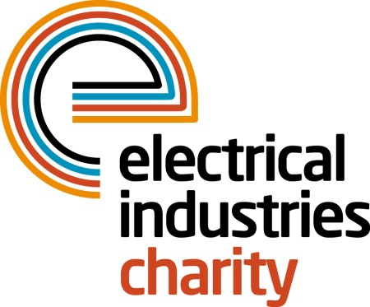
Press Release

19 February 2015

Anyone for golf?

The Electrical Industries Charity has launched its 2015 National Golf Championships which will take place at Woburn Golf Club’s Duke’s Course on Thursday 15 October.

The Electrical Industries Charity has a long history of organising golf events and currently hosts ten regional events across the UK. For the first time in 2015 these regional competitions will culminate in the National Golf Championships and each winning team from the regional competitions will be invited to take part.

The 4 Ball competition will take place on the 6,983 yard Duke's Course, which was designed by Charley Lawrie and was the first of Woburn's three courses to be constructed. It remains one of the most prestigious golf courses in the country and boasts fairways lined with heather, bracken and gorse which add to the charm of the course and provide some of the natural hazards of each hole.

Operations Manager, Jill Nadolski says: “We are delighted to be launching the inaugural National Golf Championship which promises to be a major event in the electrical industry calendar. Golf continues to be one of the UK’s most popular corporate sports and provides a great opportunity for building business relationships in a relaxed atmosphere away from the office. By bringing together some of the biggest names and best golfers in the electrical industry this event promises to provide these opportunities while raising funds to help people in our industry when they need it most.”

There are a number of sponsorship opportunities for companies who would like to be part of this prestigious event. For further information please contact Liva Viksna, Tel: 020 3696 1716; Email: liva.viksna@electricalcharity.org

www.electricalcharity.org

Note to editors
The Electrical Industries Charity is the national charity for the electrical, electronics and energy industries. It aims to look after people from these industries whenever they or their families need help with life’s challenges.

The charitable services are available to anyone who currently works or has worked in the very diverse and often converging industries, such as:
- Electrical contracting and facilities management
- Electrical and electronic manufacturing, wholesale, distribution and retail
- Electrical and mechanical engineering
- Lighting industry
- Generation, distribution and supply of electrical power, including nuclear and renewable energy

For further information about the Electrical Industries Charity please contact Keystone Communications:

Tracey Rushton-Thorpe
Tel: 07753 840386
Email: tracey@keystonecomms.co.uk

