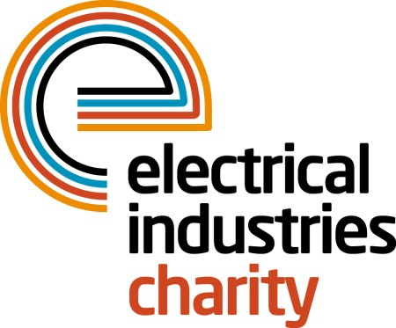
Press Release

07 May 2015

Huge success for charity runners

The Virgin Money London Marathon proved to be a huge success for the Electrical Industries Charity with charity runners raising over £33,000.

The London Marathon remains one of the biggest charity fundraising events in the UK and this year the Electrical Industries Charity had a staggering 28 runners complete the gruelling 26 mile course. But for one runner 26 miles wasn’t enough because Mark Griffiths of Reggiani not only completed the course – he did it twice, starting at 2am to run from the finish to the start before joining the rest of the runners on the official start line.

Mark commented: “In my role as a lighting designer at Reggiani I strive to create the most appropriate way to express light to make each and every project special, but none of this would be possible without the cooperation of my colleagues in the electrical, electronics and energy industries, which is why I chose to support their worthwhile cause”.

Operations Manager, Jill Nadolski says: “ I would like to say a huge thank you to everyone who took part in the Virgin Money London Marathon on behalf of the Electrical Industries Charity. Their efforts have raised a staggering amount for the Charity and we are delighted that we have had the best turnout ever for this event in the year that we celebrate our 110th anniversary.

“We have already had enquiries about places for the 2016 event and I can confirm that we will once again be offering Gold Bond places to those who would like to take part and raise funds for the Electrical Industries Charity. But it is worth remembering that if you do get a ballot place for 2016 you can still raise funds for the charity and help us to support those in our industry when they need it most.”

For further information and to apply for a 2016 Virgin Money London Marathon place please contact Stacey Burrows, email: stacey.burrows@electricalcharity.org

www.electricalcharity.org

Note to editors
The Electrical Industries Charity is the national charity for the electrical, electronics and energy industries. It aims to look after people from these industries whenever they or their families need help with life’s challenges.

The charitable services are available to anyone who currently works or has worked in the very diverse and often converging industries, such as:
- Electrical contracting and facilities management
- Electrical and electronic manufacturing, wholesale, distribution and retail
- Electrical and mechanical engineering
- Lighting industry
- Generation, distribution and supply of electrical power, including nuclear and renewable energy

For further information about the Electrical Industries Charity please contact Keystone Communications:

Tracey Rushton-Thorpe
Tel: 07753 840386
Email: tracey@keystonecomms.co.uk

