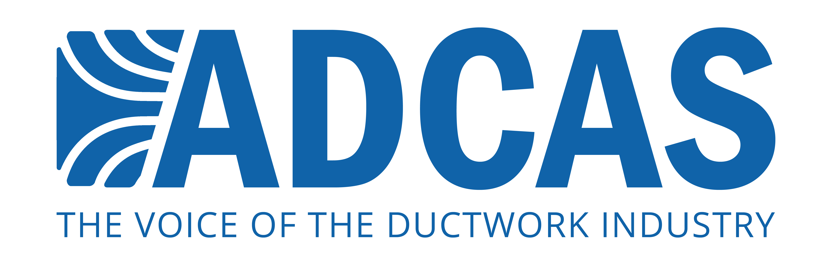

PRESS RELEASE: 4TH June 2015

ADCAS demonstrates importance of quality ductwork with BSRIA visit to ASM Engineering

BSRIA Chief Executive Julia Evans visited ADCAS (Association of Ductwork Contractors and Allied Services) member ASM Engineering in April to find out more about the manufacture of ductwork and its importance for efficient and effective buildings.

Hitchin-based ASM Engineering welcomed Ms Evans as well as Russell Beattie, Chief Executive of FETA and Malcolm Moss who is President of ADCAS. ASM Director, Bryan Welch says: “It was a pleasure to be able to showcase the engineering, and technical resources and investment needed to keep pace with modern construction techniques and fast-track deadlines.”

Julia Evans comments: “I found the trip both fascinating and informative, and at one level it was very much about working metal, which is done very effectively. However, what impressed me the most was the understanding that ASM have of their role within construction projects. They see themselves as not delivering a product but as being integral to delivering a better built environment for the end user.”

The modern ductwork sector is a highly technical field, driven by the use of virtual CAD modeling and design as well as automatic computer-controlled manufacturing techniques.

“It is rare that you get the opportunity to show people behind the scenes of a modern ductwork business,” says Mr Welch. “I think our visitors were genuinely surprised at the level of technology in use.”

ADCAS President Malcolm Moss adds: “We appreciate the time taken by the new head of BSRIA to understand the ductwork sector. These sort of visits are not only educational in terms of seeing the manufacture of ductwork, but there is great value in having discussions with people working in the industry.”

ADCAS is focused on working with its umbrella body, FETA to help the ductwork sector get to grips with issues such as BIM and the skills shortage.

Notes to editors
ADCAS is the dedicated organisation for ductwork contractors, allied suppliers and manufacturers of equipment for air conditioning. Ductwork is a vital part of air movement systems, and helps to support both comfort and health for building occupants. Quality ductwork that is manufactured and fitted to high standards is vital for energy efficient and productive operation of buildings – which is what ADCAS promotes through its work on standards and legislation in the industry.
Press contact: Karen Fletcher, Keystone Communications: karen@keystonecomms.co.uk 07775 502 598

