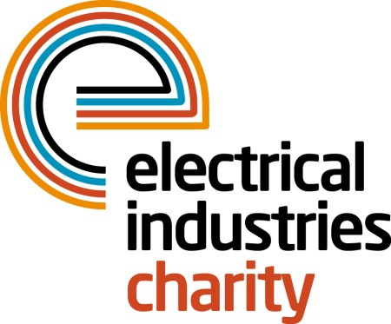
Press Release

08 January 2015

Calling all budding cyclists

You are just one step away from making this a year to remember according to the Electrical Industries Charity which has joined forces with www.cycleforcharity.com to offer amazing opportunities for people to take part in a cycle challenge in 2015.

Charity challenges offer unrivalled opportunities to cycle in some of the biggest and most exciting events around whilst raising funds which will help the Electrical Industries Charity continue to support people in the electrical industry when they need it most.

One of the many challenges on offer is the UK Coast to Coast where you can conquer the breadth of Britain by bike. Starting with your rear wheels in the Irish Sea, this challenge encompasses some of the best scenery which Britain has to offer from the stunning mountains of the Lake District to the beautiful open moors of the Northern Pennines which will almost certainly leave you wanting more.

Operations Manager, Jill Nadolski says: “At this time of year everyone needs something to look forward to so we are offering you the opportunity to banish those winter blues, get fit, have fun and raise funds for your industry charity at the same time. By joining together with cycleforcharity.com we can now offer a whole host of challenges which you, your friends and family can take part in and ensure that 2015 is a year to remember.”
So whether you want to cycle from Land’s End to John O’Groats or conquer the capital in the Ride London 100, sign up for your challenge now at www.cycleforcharity.com because the sooner you sign up the sooner you can start planning for your trip of a lifetime.

www.electricalcharity.org

Note to editors
The Electrical Industries Charity is the national charity for the electrical, electronics and energy industries. It aims to look after people from these industries whenever they or their families need help with life’s challenges.

The charitable services are available to anyone who currently works or has worked in the very diverse and often converging industries, such as:
- Electrical contracting and facilities management
- Electrical and electronic manufacturing, wholesale, distribution and retail
- Electrical and mechanical engineering
- Lighting industry
- Generation, distribution and supply of electrical power, including nuclear and renewable energy

The Confidential Helpline number is: 0800 652 1618.

For further information about the Electrical Industries Charity please contact Keystone Communications:

Tracey Rushton-Thorpe
Tel: 07753 840386
Email: tracey@keystonecomms.co.uk

