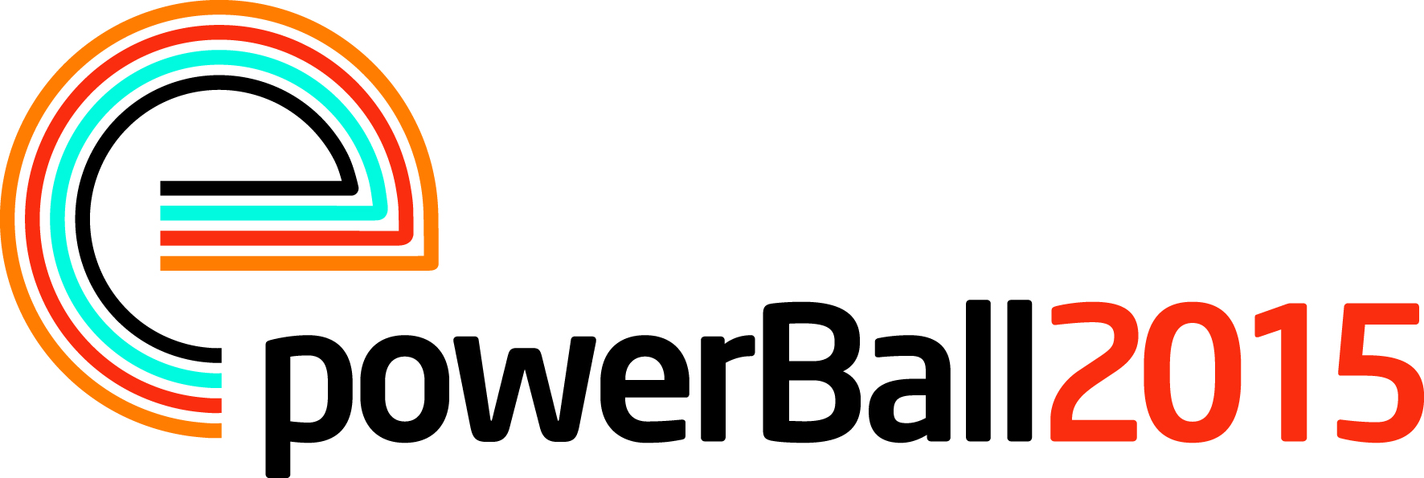
Press Release

11 March 2015

Let’s get this party started!

Tickets for PowerBall 2015, the electrical industry’s biggest party of the year are now on sale and it looks like it will be one of the biggest and best yet.

This year’s event will celebrate everything that there is to love about the Motown era and the organisers are delighted to announce that the headline act will be the spectacular, critically acclaimed, Dancing in the Streets.

Including hit songs from The Supremes, James Brown and Stevie Wonder, Dancing in the Streets will take partygoers on a journey through the incredible dance music of Motown.

Operations Manager, Jill Nadolski says: “Motown was responsible for some of the most enduring music of the 20th century and with songs like Tears of a Clown and You Can’t Hurry Love this promises to be a night to remember.”

PowerBall 2015 will also welcome back the amazing Earthlights Boogie Band who captivated the audience at last year’s event and as ever, there will be an opportunity to take part in the fun and games.

Jill continues: “Powerball has become the ‘must attend’ event for the electrical industry and we are delighted to be launching the 2015 event with a headline act which guarantees another excellent night for all of our supporters.

“Last year Powerball raised a massive £207,000 and we are very grateful to everyone who helped us to achieve this fantastic amount. We look forward to welcoming the industry back in 2015 for another glittering night of top class entertainment.”

PowerBall 2015 takes place on Friday 13 November at the Grosvenor House, Park Lane, London. Full details on ticket and sponsorship packages are available from the dedicated website www.powerball2015.com.

Note to editors
PowerBall 2015 is being run by The Electrical Industries Trading Company Limited which is a wholly owned subsidiary of the Electrical Industries Charity.

The Electrical Industries Charity is the national charity for the electrical, electronics and energy industries. It aims to look after people from these industries whenever they or their families need help with life’s challenges.

The charitable services are available to anyone who currently works or has worked in the very diverse and often converging industries, such as:
- Electrical contracting and facilities management
- Electrical and electronic manufacturing, wholesale, distribution and retail
- Electrical and mechanical engineering
- Lighting industry
- Generation, distribution and supply of electrical power, including nuclear and renewable energy

www.electricalcharity.org

For further information about powerBall 2015 please contact Keystone Communications:

Tracey Rushton-Thorpe
Tel: 07753 840386
Email: tracey@keystonecomms.co.uk

