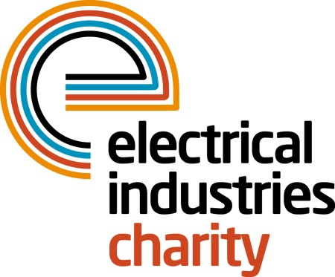
Press Release

02 March 2015

Keep on running

Spring is in the air so why not put a spring in your step by taking part in a sponsored run for the Electrical Industries Charity.

The Charity has joined forces with www.runforcharity.com to give the electrical industry access to a wide range of running events which include the Milton Keynes half marathon, The Mudnificent Seven as well as a number of fun runs and 5K races across the UK.

Running is a fabulous way to stay in shape and keep fit and signing up to a sponsored run to raise funds on behalf of your industry charity gives you a great reason to stick to your training plan.

Operations Manager, Jill Nadolski says: “We are delighted to be able to offer this great opportunity to take part in a wide range of charity running events. Millions of pounds are raised every year by charity runners and by taking part in just one event you can make a big difference to the lives of people in our industry when they need assistance.

“Whether you are a complete beginner, returning to running after a break or a seasoned racer you will find plenty of events to choose from so why not pick an event and start your run for charity journey today.”

Whether you fancy taking part in a half marathon or a more leisurely 5K, sign up for an event now at www.runforcharity.com and put your training plan into action.

www.electricalcharity.org

Note to editors
The Electrical Industries Charity is the national charity for the electrical, electronics and energy industries. It aims to look after people from these industries whenever they or their families need help with life’s challenges.

The charitable services are available to anyone who currently works or has worked in the very diverse and often converging industries, such as:
- Electrical contracting and facilities management
- Electrical and electronic manufacturing, wholesale, distribution and retail
- Electrical and mechanical engineering
- Lighting industry
- Generation, distribution and supply of electrical power, including nuclear and renewable energy

For further information about the Electrical Industries Charity please contact Keystone Communications:

Tracey Rushton-Thorpe
Tel: 07753 840386
Email: tracey@keystonecomms.co.uk

