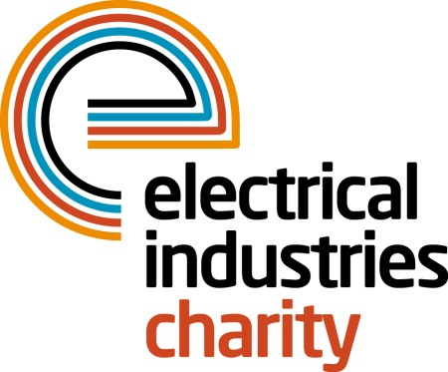
Press Release

01 June 2015

Where there’s a Will there’s a way

The Electrical Industries Charity is urging everyone in the industry to make a Will to ensure that your estate is shared amongst the important people in your life when you’re gone.

Coming to the end of our days is something which many people find difficult to talk about but if you want to protect the people you love then you need to make your wishes known – regardless of your circumstances.

Operations Manager, Jill Nadolski says: “There are a number of reasons why people don’t make a Will, for example, if they are a ‘nuclear family’– married (once) with kids – most people think that you haven’t got too much to worry about. But you should still make a will to appoint guardians for your children, to guarantee control of your assets and most importantly to make it easier for your family in the event of your death. If your circumstances are more complicated then you need a Will to make sure that there’s no confusion about who’s meant to get what. This is especially true if you have a business where you might also have a business partner, contracts, customers and staff to consider. Not making a Will means leaving everything up in the air and any uncertainty could leave the future of your business in jeopardy.

“Ultimately making a will isn’t a big deal but it is important to get it right which is why engaging the services of a professional is sensible. As a Charity we have selected RIFT Wills as our preferred partner and as a result if you are employed by a JIB member company they will donate 10% of the fee for drawing up a Will to the Electrical Industries Charity – which is another good reason to make a Will.”

If you’re still not convinced then perhaps you should look upon it as an opportunity to help people because you can also leave a charitable gift in your will – ensuring that you can continue to help others after you have gone.

For more information and to enquire about making a Will you can contact RIFT Wills on 01233 653983.

www.electricalcharity.org

Note to editors
The Electrical Industries Charity is the national charity for the electrical, electronics and energy industries. It aims to look after people from these industries whenever they or their families need help with life’s challenges.

The charitable services are available to anyone who currently works or has worked in the very diverse and often converging industries, such as:
- Electrical contracting and facilities management
- Electrical and electronic manufacturing, wholesale, distribution and retail
- Electrical and mechanical engineering
- Lighting industry
- Generation, distribution and supply of electrical power, including nuclear and renewable energy

For further information about the Electrical Industries Charity please contact Keystone Communications:

Tracey Rushton-Thorpe
Tel: 07753 840386
Email: tracey@keystonecomms.co.uk

