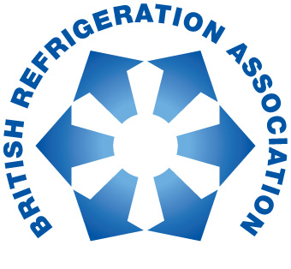

PRESS RELEASE: 15 September, 2015

BRA introduces report on putting into use replacement refrigerants

The British Refrigeration Association (BRA) has responded to the challenges to industry as a result of the new F Gas Regulation with an expert guide on coping with the changes to availability of common refrigerants, and the need to use new refrigerants. The guide is titled Putting into Use Replacement Refrigerants (PURR) and has been produced by experts from the Association with the support of external consultants.

BRA President, Mike Lawrence, says: “Our aim is to help people find an appropriate response to the F-Gas regulation that has come from the EU. The PURR Report highlights the very real challenges that clients in sectors such as retail refrigeration will face as a result of F-Gas.”

The PURR Report highlights the fact that from the start of 2015 a ‘cap and phase down’ was introduced which seeks to reduce the amount of HFC refrigerants placed on the market. The cap and phase down does not ban the sale of any particular HFC, instead it will limit the total supply of all HFCs across the EU based on the total tonnes CO₂ equivalent.

Under the EU F-Gas regulation there will also be a ban from 2020 on new equipment using refrigerants with a global warming potential (GWP) of more than 2500. There will also be a ban on using such refrigerants for servicing existing systems from the same date.

As a result of these changes there is a real risk of refrigerant supply shortages and that virgin R404A availability may become limited, so existing R404A systems will have to be replaced, or have a change of refrigerant. However, there are so many of these systems in use now that many will have to rely on reclaimed or recycled refrigerant for servicing.

Mike Lawrence says: “There can be no doubt that the F-Gas regulation will have an impact on the market for certain refrigerants. For example, companies using R404A in their systems must ensure that the refrigerant is reclaimed and kept for future servicing. This is a very different approach to the one that we have been used to.”

The PURR Report offers valuable insights into the impact of the F-Gas regulation on refrigerants, which are intended to give readers a firm foundation for developing a strategic response for their businesses.

“There can be no doubt that spending money on dealing with F-Gas regulation will not be welcomed by the financial directors of most businesses that are affected,” says Mr Lawrence. “However, the PURR Report gives a clear indication of possible approaches to dealing with phase down, and the BRA hopes that this will support good practice.”

The PURR Report was produced by a BRA Action Group and supported by BRA members. The Report will be available, free of charge, from the BRA section of the FETA website: www.feta.co.uk/associations/bra/publications

-ends-

Press enquiries to: Karen Fletcher, karen@keystonecomms.co.uk 07775 502 598

About BRA:
The British Refrigeration Association (B.R.A.) is the only trade association representing manufacturers, importers, wholesalers, distributors, contractors, specifiers and end-users of refrigeration plant, equipment and components.
It also includes producers of refrigerants and lubricants, colleges and training establishments. It works closely with government, public bodies and other organisations, both in the UK and overseas, to further the interests of the refrigeration industry. BRA was originally formed in 1940 under the name "Commercial Electric Refrigeration Association". It has worked continuously since 1940, as C.E.R.A., B.R.A., B.R.A.C.A and now again B.R.A. to promote the interests of the Refrigeration Industry.

