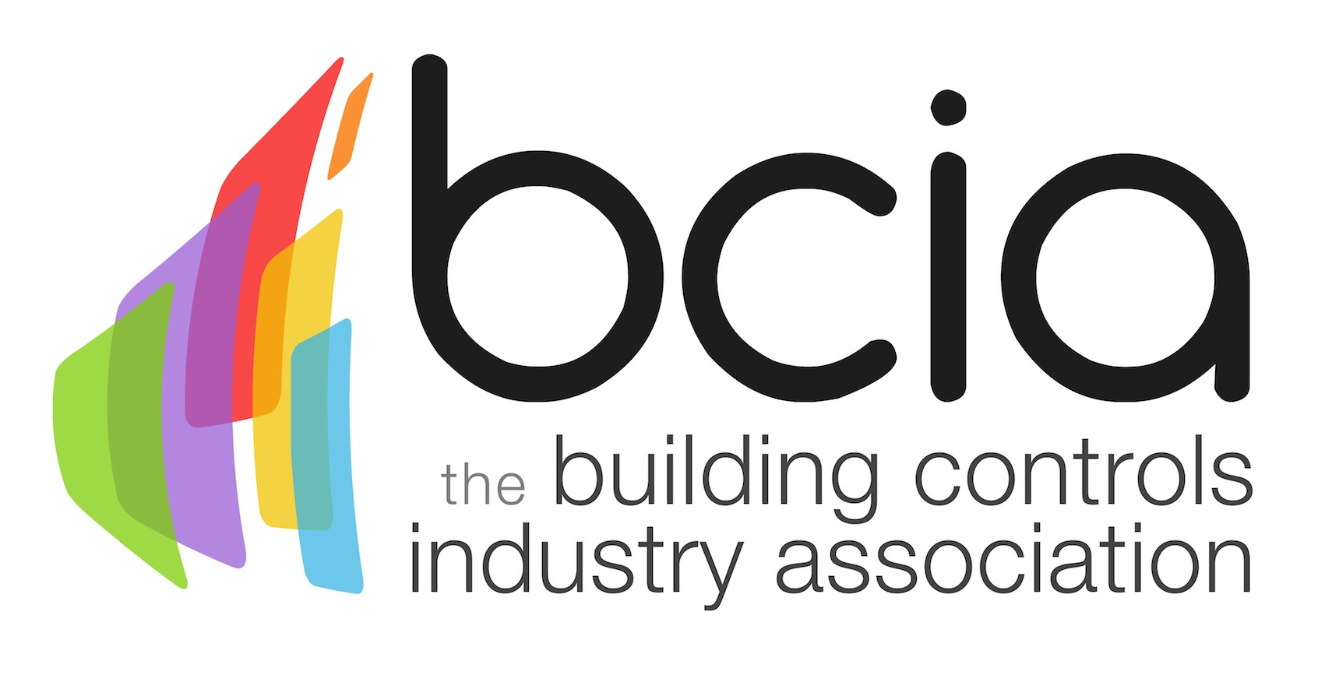

Press Release

06 October 2015

Entries go live for the 2016 BCIA Awards

Entries are now open for the 2016 Building Controls Industry Association (BCIA) Awards which promise to be bigger and better than ever before.

The BCIA Awards are the premier event in the building controls calendar and in 2016 this highly anticipated awards ceremony, which takes place on Thursday 12 May 2016, will move to a brand new venue - the Hilton Birmingham Metropole.

The perfect venue for this growing event, the Hilton Birmingham Metropole will provide a fantastic opportunity for guests to network with key decision makers whilst celebrating the best of the best in the building controls industry.

Now in their 10th year, the awards recognise and reward excellence in the building controls industry providing entrants with a fantastic opportunity to showcase their top products and projects from the past 12 months.

There are eight categories which include; Independent Building Controls and BEMS Installer; Best Service and Maintenance Provider; Technical Innovation of the Year - Projects; Technical Innovation of the Year - Products; Energy Management Award; Contribution to Training; Engineer of the Year and Student of the Year.
Steve Harrison, President of the BCIA says: “The BCIA Awards show that the spirit of innovation and the drive of technology are moving us forward in our industry. It’s important for everyone to celebrate these achievements and be recognised for professional excellence.

“I would encourage everyone within the building controls industry to enter and be recognised for their success in this challenging market. The awards are an opportunity to put forward your nominations for the best performers in the industry and celebrate the great work which continues to put controls at the forefront of the building services industry.”

The deadline for entries is the 29 January 2016. To enter simply visit the dedicated awards website, www.bcia-awards.co.uk, and submit your entries via the online form. Entry to the awards is free and open to BCIA members and non-members.

www.bcia-awards.co.uk

Note to editors
The Building Controls Industry Association (BCIA) represents the UK building controls and BEMS sector. With around 75 members accounting for 70% of the UK controls market, the BCIA is an influential group that promotes better specification, application and use of controls. The BCIA also offers its own training courses and the Building Controls Professional Assessment (BCPA).

For further information about the BCIA please contact Keystone Communications:

Tracey Rushton-Thorpe
Tel: 07753 840386
Email: tracey@keystonecomms.co.uk

