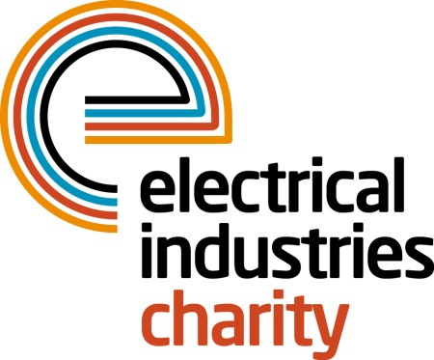
Press Release

06 October 2015

Time is running out to get your place in the 2016 Virgin Money London Marathon

The Electrical Industries Charity is delighted to announce that it has places available for the Virgin Money London Marathon which takes place on Sunday 24 April 2016.

Those who didn’t manage to secure a place for the big event in the public ballot can now apply for Gold Bond places and be in the running for a chance to support a fantastic cause.

The London Marathon remains one of the biggest charity fundraising events in the UK and running for the charity will help to raise much needed funds to help those in our industry when they need it most.

Earlier this year charity runners took to the streets of London raising a massive £33,000 for the Electrical Industries Charity and the aim is to beat that amount in 2016.

To ensure runners enjoy every step of their marathon experience in 2016, every runner who is accepted will receive a special running vest and support from the Charity’s dedicated events team in the lead up to the exciting day.

Running for the Electrical Industries Charity gives people an opportunity to help others in their industry and support a cause they truly care about.

If you would like to apply for a gold bond place please contact Stacey Burrows, email: stacey.burrows@electricalcharity.org, by 15 October. Applicants are required to raise a minimum amount of £1,750 and pay a registration fee of £45.00.

www.electricalcharity.org

Note to editors
The Electrical Industries Charity is the national charity for the electrical, electronics and energy industries. It aims to look after people from these industries whenever they or their families need help with life’s challenges.

The charitable services are available to anyone who currently works or has worked in the very diverse and often converging industries, such as:
- Electrical contracting and facilities management
- Electrical and electronic manufacturing, wholesale, distribution and retail
- Electrical and mechanical engineering
- Lighting industry
- Generation, distribution and supply of electrical power, including nuclear and renewable energy

For further information about the Electrical Industries Charity please contact Keystone Communications:

Tracey Rushton-Thorpe
Tel: 07753 840386
Email: tracey@keystonecomms.co.uk

