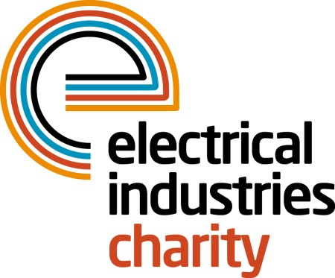
Press Release

24 November 2015

PowerBall is a huge success

The Electrical Industries Charity is delighted to announce that PowerBall, the industry’s biggest and best party of the year, was a massive success raising £236,000.

Over 1000 guests enjoyed a night of glittering entertainment which included some of the best music from the Motown era. The headline entertainment, Dancing in the Streets, took guests on a journey through the incredible sound of Motown including music by artists such as The Supremes, James Brown and Stevie Wonder.

The special guest of the evening was 23-year-old, Brendan Mosley, who was in desperate need of additional funding to attend university and fulfil his dream of becoming an engineer. Brendan is now studying for his engineering degree at Huddersfield University and the charity was able to help him by giving him a grant of £500 each term for books and supplies.

Speaking at this year’s PowerBall, Brendan said: “It’s very difficult to fund your own degree and I am very thankful for the help that I received from the Charity.”

Managing Director, Tessa Ogle says: “PowerBall is an opportunity for our industry to come together and support each other in times of difficulty. Brendan is one of the many people who have benefited from the help and support of the charity and we are so pleased we were able to help him achieve his dreams.

“Every year the amount of money which we raise at PowerBall continues to surpass our expectations and I would like to take this opportunity to say a big thank you to everyone who attended and took part in the many fundraising activities on the night – without you the help and support which we gave to Brendan would not be possible.”

Next year PowerBall will take place on Friday 11 November at the Grosvenor House Hotel, London.

www.electricalcharity.org

Note to editors
The Electrical Industries Charity is the national charity for the electrical, electronics and energy industries. It aims to look after people from these industries whenever they or their families need help with life’s challenges.

The charitable services are available to anyone who currently works or has worked in the very diverse and often converging industries, such as:
- Electrical contracting and facilities management
- Electrical and electronic manufacturing, wholesale, distribution and retail
- Electrical and mechanical engineering
- Lighting industry
- Generation, distribution and supply of electrical power, including nuclear and renewable energy

For further information about the Electrical Industries Charity please contact Keystone Communications:

Tracey Rushton-Thorpe
Tel: 07753 840386
Email: tracey@keystonecomms.co.uk

