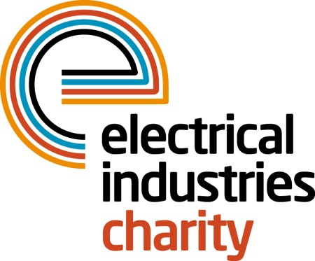
Press Release

30 October 2015

Tessa Ogle joins Electrical Industries Charity

The Electrical Industries Charity is delighted to welcome Tessa Ogle as the new Managing Director.

An experienced general management professional with an extensive track record in leading business growth, Tessa joins the charity from Parsons Brinckerhoff (a Balfour Beatty company) where she held the position of National General Manager for Oil & Gas.

Tessa says: “Since the Electrical Trades Benevolent Institution was founded in 1905 the charity has continued to evolve and now provides financial relief and practical support to more people in the electrical related industries than ever before.

“Two thirds of our current beneficiaries are of working age but the majority are ‘economically inactive’ due to redundancy, illness, injury or caring responsibilities. Our aim as a charity is to reach more working people and provide the support which is essential to them.

“This is therefore a very exciting time to be joining the Electrical Industries Charity and I look forward to working with the industry to ensure that we continue to provide help and support to our people when they need it most.”

Under Tessa’s leadership the Charity will focus on four key programmes, the Apprenticeship Support Programme; Employee and Family Support Programme; Pensioner Support Programme and a Practical Participation Programme.

www.electricalcharity.org

Note to editors
The Electrical Industries Charity is the national charity for the electrical, electronics and energy industries. It aims to look after people from these industries whenever they or their families need help with life’s challenges.

The charitable services are available to anyone who currently works or has worked in the very diverse and often converging industries, such as:
- Electrical contracting and facilities management
- Electrical and electronic manufacturing, wholesale, distribution and retail
- Electrical and mechanical engineering
- Lighting industry
- Generation, distribution and supply of electrical power, including nuclear and renewable energy

For further information about the Electrical Industries Charity please contact Keystone Communications:

Tracey Rushton-Thorpe
Tel: 07753 840386
Email: tracey@keystonecomms.co.uk

