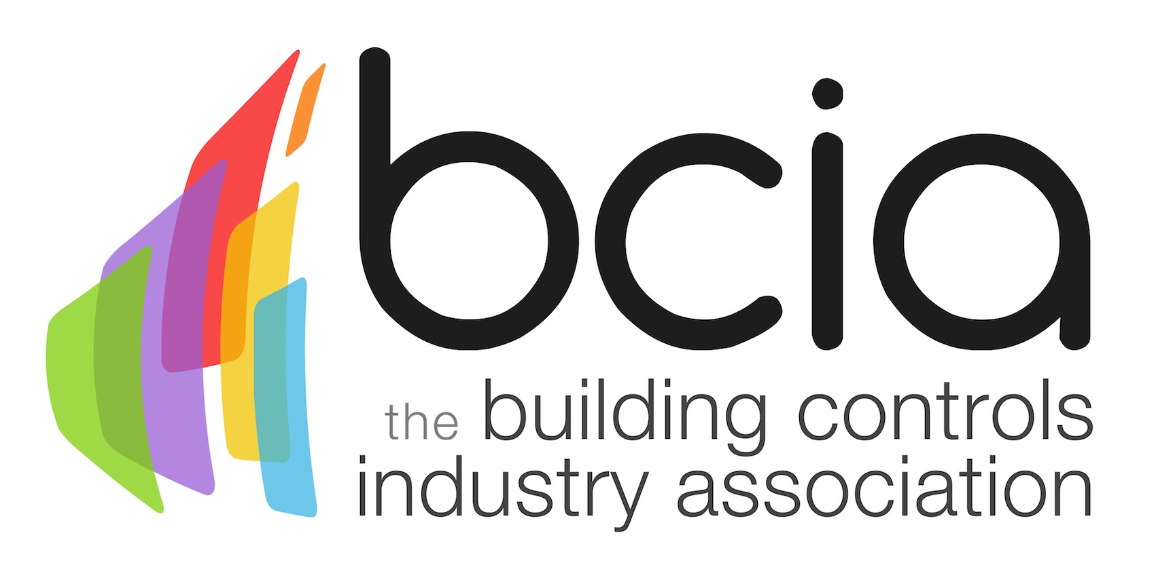

Press Release

30 November 2015

Do you have what it takes to be a winner?

Could you be the next winner at the 2016 BCIA Awards? There’s still time to get your entries in for the biggest event in the building controls calendar.

Now in their 10th year, the awards celebrate excellence in the building controls industry, providing entrants with a fantastic opportunity to showcase their best projects and products from the past twelve months.

In 2015, Impact Control Systems were commended for their work on Matalan’s HQ, winning the Technical Innovation of the Year- Projects award, sponsored by Johnson Controls.

Impact Control Systems installed a BEMS at the Matalan HQ site which fully controls all HVAC across several buildings on a dedicated network. The controls strategy they used focused on distributed zoning and demand–based control to optimise energy use.

Terry Sharp, Manager of Product Sales at Johnson controls, said: “The aim of the awards is to recognise and reward innovation and celebrate energy efficiency in our market place – the installation by Impact Control Systems provides a perfect example of this being put into practice.”

There are eight categories to consider this year; Independent Building Controls and BEMS Installer; Best Service and Maintenance Provider; Technical Innovation of the Year - Projects; Technical Innovation of the Year - Products; Energy Management Award; Contribution to Training; Engineer of the Year and Student of the Year.
The highly anticipated awards ceremony will take place on Thursday 12 May 2016 at a brand new venue – the Hilton Birmingham Metropole where guests will also enjoy a glittering night of entertainment provided by comedian and actor, Rufus Hound.

The deadline for entries is Tuesday 29 January 2016. To enter simply visit the dedicated awards website, www.bcia-awards.co.uk, and submit your entries via the online form. Entry to the awards is free and open to BCIA members and non-members.

www.bcia.co.uk

Note to editors
The Building Controls Industry Association (BCIA) represents the UK building controls and BEMS sector. With around 75 members accounting for 70% of the UK controls market, the BCIA is an influential group that promotes better specification, application and use of controls. The BCIA also offers its own training courses and the Building Controls Professional Assessment (BCPA).

For further information about the BCIA please contact Keystone Communications:

Tracey Rushton-Thorpe
Tel: 07753 840386
Email: tracey@keystonecomms.co.uk

