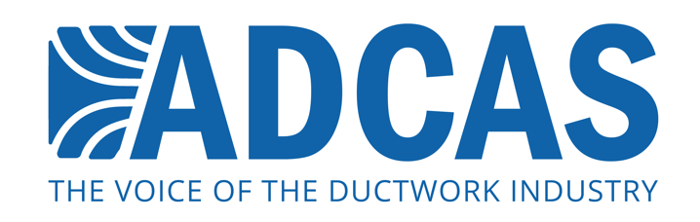

PRESS RELEASE: 7th December, 2015

ADCAS releases new guide for ductwork ‘in the real world’

The Association of Ductwork Control Contractors and Allied Services (ADCAS) has launched a free publication that explains some complex guidance on ductwork cleaning and access doors. The publication examines the current legislation and standards, and gives a clear insight on how contractors can apply these in their professional practice.

The ADCAS Guide to Ductwork Cleaning Requirements and Access Doors examines the content of:
* DW/144 Second Edition (2013)
* TR/19 Second Edition (2013)
* BS EN 15780 (2011).

The Guide explains the similarities and differences between these documents. The publication offers practical recommendations for ductwork contractors, system designers, and cleaning contractors to help them work with all three publications.

The Guide has been a joint effort by ADCAS members who have worked together to offer practical advice on cleaning access, duct cleanliness and access doors. It is a well-established fact that ductwork air systems can be a source of spreading disease and infections. With greater understanding of these issues, the requirements for access into the ductwork systems for maintenance, inspection and cleaning have increased.

The Guide therefore provides guidance on the cleanliness requirements for both existing and new ductworks. It also looks at the location and size of access doors and the cleaning and maintenance of ventilation systems which are very closely linked.

The publication is aimed at ductwork installers and also those responsible for the long-term maintenance of ductwork. The guide covers important issues, including information on how to deliver, protect and install new ductwork, location of access doors and access into large ductwork for cleaning.

The document also includes a pre-contract checklist that helps industry professionals to establish the requirements for each system from the outset, prior to a contract being awarded and started on site. Industry professionals will also benefit from the section on frequently asked questions.

The publication is free, and it can be downloaded from the ADCAS website: www.adcas.co.uk

Note to Editors

The Association of Ductwork Contractors and Allied Services (ADCAS) was formed in 1997 by leading ductwork contractors who believed that the industry needed an independent voice and a specific identity. ADCAS is part of FETA (the Federation of Environmental Trade Associations). ADCAS works in partnership with other organisations such as B&ES and BSRIA in order to promote better specification, design and installation of ductwork.

ADCAS is a dedicated organisation for ductwork contractors, allied suppliers and manufacturers of equipment for ventilation and air conditioning. Ductwork is a vital part of air movement systems, and helps to support both comfort and health for building occupants. Quality ductwork that is manufactured and fitted to high standards is vital for energy efficient and productive operation of buildings – which is what ADCAS promotes through its work on standards and legislation in the industry.

Press contact:

Monika Gaubyte or Karen Fletcher

Keystone Communications
Monika@keystonecomms.co.uk
Karen@keystonecomms.co.uk

