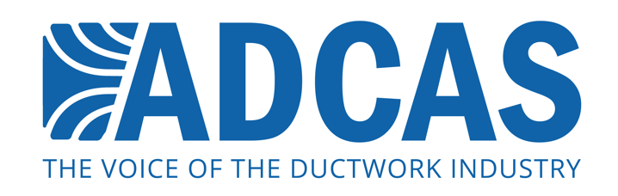
XX XXXX 2016

ADCAS highlights the importance of good quality ductwork

The Association of Ductwork Control Contractors and Allied Services (ADCAS) is urging the construction industry to pay attention to quality when purchasing ductwork.

Ductwork is a very important element of a building which is often overlooked at the design and specification stages. However, ductwork influences energy efficiency and indoor air quality. As a result, it can impact on occupants’ health and wellbeing as well as long-term operating costs.

ADCAS believes that low-priced ductwork can be linked to poor quality in the manufacturing and installation processes. This in turn leads to poor outcomes for building owners and occupiers.

ADCAS President, Malcom Moss, says: "Ductwork should not be bought solely on the basis of cheapest price. This almost inevitably leads to under-performance of air movement systems that will have a significant impact on the operation of a building in terms of both cost and comfort."

Ductwork is a technology that requires experience not only in manufacturing, but also in dealing with the challenges that can arise on site when installation is underway.

"This is a key area where quality and expertise matter," adds Moss. "ADCAS members have knowledge and experience so they know how best to install and contract projects so that works are carried out smoothly."

What’s more, there is a host of legislation and guidance on ductwork that specifiers, contractors, and building owners should be aware of. The legislation covers fire safety, cleaning, manufacturing and installation standards. It is important to consider whether a ductwork supplier understands the industry standards and rules.

In order to measure up to these regulations and to enhance the lifetime performance of ductwork, specifiers and end-users should deal with reputable suppliers at all times. ADCAS has recently published a Guide to Ductwork Cleaning & Access which highlights the sort of rules that reputable ductwork manufacturers and installers should be aware of.

Malcom Moss says: “Contractors who choose to go down the cheaper route when purchasing ductwork are more likely to get poor quality product. Those who are looking for a whole-life product should be dealing with reputable suppliers, such as members of ADCAS, and thinking about the long-term costs of their ductwork selection.”

For more information, visit: www.adcas.co.uk

Note to Editors

The Association of Ductwork Contractors and Allied Services (ADCAS) was formed in 1997 by leading ductwork contractors who believed that the industry needed an independent voice and a specific identity. ADCAS is part of FETA (the Federation of Environmental Trade Associations). ADCAS works in partnership with other organisations such as B&ES and BSRIA in order to promote better specification, design and installation of ductwork.

ADCAS is a dedicated organisation for ductwork contractors, allied suppliers and manufacturers of equipment for ventilation and air conditioning. Ductwork is a vital part of air movement systems, and helps to support both comfort and health for building occupants. Quality ductwork that is manufactured and fitted to high standards is vital for energy efficient and productive operation of buildings – which is what ADCAS promotes through its work on standards and legislation in the industry.

Press contact:

Monika Gaubyte or Karen Fletcher
Keystone Communications
Monika@keystonecomms.co.uk
Karen@keystonecomms.co.uk

