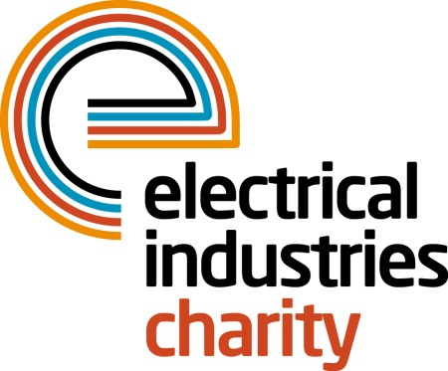
Press Release

18 January 2016

Apprentices gain access to help and support

The Electrical Industries Charity has teamed up with JTL, the leading work-based training provider of electrical apprentices across England and Wales, and the Scottish Electrical Charitable Training Trust (SECTT), to launch the Apprentice Support Programme.

Designed to help young people deal with some of the key challenges that affect them as they work towards their apprenticeship, the Programme offers independent advice and information through the Confidential Helpline (0800 652 1618) on a wide variety of issues, such as rising debt and problems at home or work.

The Charity has also partnered with a leading provider of interactive online career management to offer career development advice, which is available as part of the Programme, through a ‘work friend’ portal.

Managing Director, Tessa Ogle says: “Apprenticeships provide a real opportunity for the bright young stars of the future but becoming an apprentice is by no means easy and the need to balance work and study can be tough. If there are added pressures in your personal life this can often be an obstacle that is difficult to overcome.

“The launch of the Apprentice Support Programme recognises our stewardship role in building resilience for the young lifeblood of our industry. By providing help when, and where it is needed most the industry is able to look after its most important asset – our people.”

www.electricalcharity.org

Note to editors
The Electrical Industries Charity is the national charity for the electrical, electronics and energy industries. It aims to look after people from these industries whenever they or their families need help with life’s challenges.

The charitable services are available to anyone who currently works or has worked in the very diverse and often converging industries, such as:
- Electrical contracting and facilities management
- Electrical and electronic manufacturing, wholesale, distribution and retail
- Electrical and mechanical engineering
- Lighting industry
- Generation, distribution and supply of electrical power, including nuclear and renewable energy

For further information about the Electrical Industries Charity please contact Keystone Communications:

Tracey Rushton-Thorpe
Tel: 07753 840386
Email: tracey@keystonecomms.co.uk

