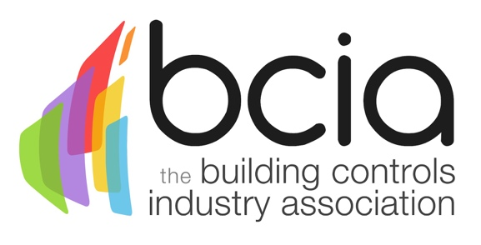

BCIA Announces appointment of two new Training Partner organisations to deliver its specialist controls courses

The Building Controls Industry Association (BCIA) has appointed two organisations to work alongside the Association to help deliver its well-known training courses to a wider audience.

Sontay and British Gas, both BCIA member companies, have been appointed Training Partner organisations. They will be the only other organisations outside the BCIA itself that can offer the Building Controls training courses (BC0 to BC6). Sontay will be offering the courses from its headquarters at Edenbridge in Kent. British Gas courses will be delivered in Rotherham. Both Training Partners will be offering courses from early March 2016.

Karen Fletcher, BCIA Executive Officer has been helping to deliver the BCIA courses from its Penkridge site for the last few years. She comments: "We have seen demand for the courses grow, and following enquiries from some of our members, the BCIA decided to take on Training Partners to ensure we can continue to deliver the courses to our industry."

The courses will all contain the same content wherever they are delivered. And the BCIA will continue to be the sole issuer of course certificates.

“We are thrilled to be an official training partner for the BCIA,” comments Sandy Damm, Managing Director at Sontay. “Sontay has always placed a high importance on training and we have an excellent training programme in our Sontay Academy. Launched in 2014, the Academy offers a wide variety of courses and can contribute to CPD activity through the Wireless, Water & Heat Metering and Smart Communication courses. Partnering with the BCIA is proof of our commitment to training and we are looking forward to a bright working relationship.”

Lynsey Partlow, Head of Training Services at British Gas, says: “We’re very excited to be appointed as an official Training Partner to the BCIA. As a provider of building control management systems to businesses across the country, we’re committed to raising standards and building vital skills in the industry.

“These new courses allow us both to enhance the training of our own engineers and provide additional support to the thousands of others we train each year.”

Karen Fletcher says: "We look forward to working with our Training Partners, who will also be helping to ensure that the courses are kept up-to-date and relevant for the fast-moving controls industry."

Dates of all courses from the BCIA and its Training Partners will be on the BCIA website www.bcia.co.uk/training.
www.bcia.co.uk

Note to editors
The Building Controls Industry Association (BCIA) represents the UK building controls and BEMS sector. With around 75 members accounting for 70% of the UK controls market, the BCIA is an influential group that promotes better specification, application and use of controls. The BCIA also offers its own training courses and the Building Controls Professional Assessment (BCPA).

For further information about the BCIA please contact Keystone Communications: Karen Fletcher karen@bcia.co.uk

