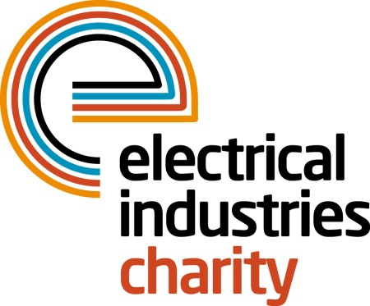

Press Release

04 January 2016

Dream big with the Electrical Industries Charity

The Electrical Industries Charity is delighted to be helping a young electrician, Brendan Moseley, in fulfilling his dream of becoming an engineer.

Brendan who is currently at Huddersfield University studying for a BSc in Engineering, has received financial support from the charity throughout his course. This includes a grant of £500 each term to help him pay for books and any other supplies he might need.

Brendan faced a number of life challenges before his studies but he was determined not to let his misfortune hold him back. After being made redundant from his last job as an electrical apprentice, Brendan’s ambition turned to studying for a degree.

When Brendan applied for university he thought it was out of reach due to the financial strain of fees and living costs, until The Electrical Industries Charity stepped in.

Brendan said: “It's very difficult to fund your own degree and I am very thankful for the help that I received from the Charity.”

Managing Director, Tessa Ogle says: “The charity is thrilled to be helping Brendan follow his dreams of becoming an engineer. He has worked extremely hard to achieve his goals and deserves every bit of success. We regularly receive updates on his progress and it certainly looks like he has a bright future ahead of him.

“Brendan has shown us how truly life-changing our work can be and we will continue to make a difference for those in our industry, supporting them in whichever way they need.”

Now in his final year, Brendan is hoping to receive a 2.1 classification for his degree and start his career as an engineer in the near future.

www.electricalcharity.org

Note to editors
The Electrical Industries Charity is the national charity for the electrical, electronics and energy industries. It aims to look after people from these industries whenever they or their families need help with life’s challenges.

The charitable services are available to anyone who currently works or has worked in the very diverse and often converging industries, such as:
- Electrical contracting and facilities management
- Electrical and electronic manufacturing, wholesale, distribution and retail
- Electrical and mechanical engineering
- Lighting industry
- Generation, distribution and supply of electrical power, including nuclear and renewable energy

For further information about the Electrical Industries Charity please contact Keystone Communications:

Tracey Rushton-Thorpe
Tel: 07753 840386
Email: tracey@keystonecomms.co.uk

