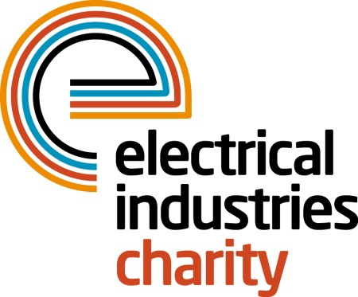
Press Release

05 February 2016

Enter the Dragon

The Electrical Industries Charity is delighted to announce its first ever Dragon Boat event and is urging companies to sign up for what promises to be an unforgettable experience.

Taking place on Saturday 06 August 2016 at Peterborough rowing lake, the Dragon Boat event will bring together industry professionals to raise money for those who need it the most.

Managing Director, Tessa Ogle says: “This is our first ever Dragon Boat event which will bring together a wide range of companies from our industry for a fun filled day of friendly rivalry. It is a fantastic way to re-ignite your team spirit and enjoy the fastest growing water activity in Britain with your friends, family and colleagues.”

Do you think your team has what it takes to line up against its industry rivals and be a winner? Companies can sign up their team of 11 for the standard package which costs just £1,000 and includes a £300 donation to the Electrical Industries Charity. Teams can also take up the fundraising challenge as the team raising the most money will be awarded the Charity trophy on the day.

The Charity is offering an additional three ultimate packages for £1,750 which includes a donation of £550 and ensures that your company logo will be featured, not only on one of the Dragon Boats, but across all of the marketing materials for the event.

Spectators are also welcome as the venue will offer plenty of entertainment including fairground rides, a bouncy castle and many more fun activities for all the family.

Why not sign up today - for more information contact, Stacey Burrows: Stacey.Burrows@electricalcharity.org

www.electricalcharity.org

Note to editors
The Electrical Industries Charity is the national charity for the electrical, electronics and energy industries. It aims to look after people from these industries whenever they or their families need help with life’s challenges.

The charitable services are available to anyone who currently works or has worked in the very diverse and often converging industries, such as:
- Electrical contracting and facilities management
- Electrical and electronic manufacturing, wholesale, distribution and retail
- Electrical and mechanical engineering
- Lighting industry
- Generation, distribution and supply of electrical power, including nuclear and renewable energy

For further information about the Electrical Industries Charity please contact Keystone Communications:

Tracey Rushton-Thorpe
Tel: 07753 840386
Email: tracey@keystonecomms.co.uk

