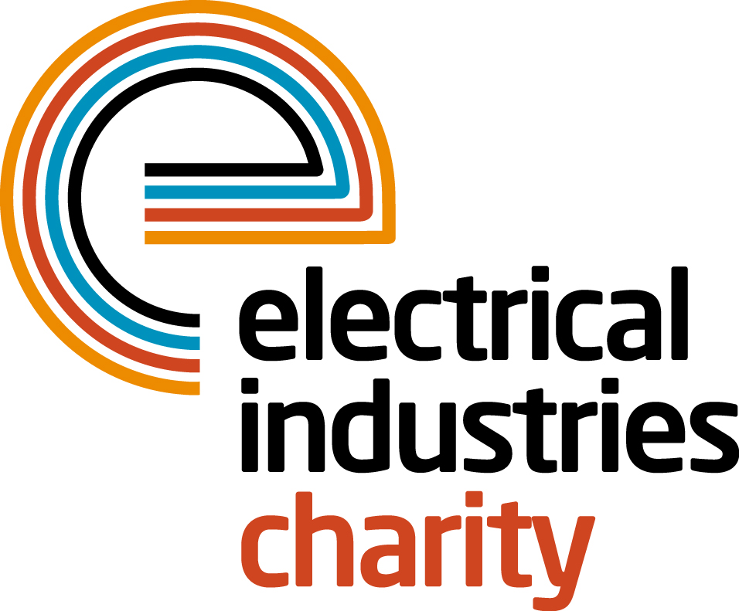
Press Release

07 January 2016

The Electrical Industries Charity joins the Queen for tea

The Electrical Industries Charity is delighted to be taking part in The Patron’s Lunch – an event which will honour The Queen’s patronage of over 600 charities and organisations on the occasion of her 90th Birthday.

The Patron’s Lunch is an iconic event that celebrates a lifetime dedicated to service and support that our Monarch has given to the community over her 63-year reign. The spectacular event will take place on Sunday 12 June 2016, where The Mall will be transformed into one of the biggest, classic British street parties.

Her Majesty the Queen has been a Patron for the Electrical Industries Charity for many years and as a result the Charity will be among the 10,000 guests who are expected to attend The Patron’s Lunch; the majority of which will be representatives of the Patron’s Organisations.

Her Majesty the Queen will join the event with the Duke of Edinburgh and other members of the Royal family including The Duke of Cambridge and Prince Harry, who will reside as Joint Presidents of The Patron’s Lunch.

The general public will be able to show their support to Her Majesty The Queen and enjoy the festivities in three different London locations: Green Park, St. James’s Park and the Royal Park. The general public across the nation will also be invited to take part in this celebration and re-ignite the community spirit by hosting their own street party outside their homes.

Managing Director, Tessa Ogle says: “We are delighted to be part of this historic and memorable celebration. The Electrical Industries Charity is honoured to have The Queen as its Patron and this event is a fantastic way for us to honour the dedication shown by Her Majesty to so many charities and organisations throughout her lifetime.”

www.electricalcharity.org

Note to editors
The Electrical Industries Charity is the national charity for the electrical, electronics and energy industries. It aims to look after people from these industries whenever they or their families need help with life’s challenges.

The charitable services are available to anyone who currently works or has worked in the very diverse and often converging industries, such as:
- Electrical contracting and facilities management
- Electrical and electronic manufacturing, wholesale, distribution and retail
- Electrical and mechanical engineering
- Lighting industry
- Generation, distribution and supply of electrical power, including nuclear and renewable energy

For further information about the Electrical Industries Charity please contact Keystone Communications:

Tracey Rushton-Thorpe
Tel: 07753 840386
Email: tracey@keystonecomms.co.uk

