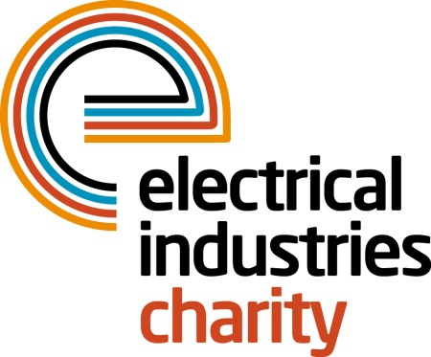
Press Release

26 January 2016

The Electrical Industries Charity announces the sad loss of Ray Hall

The Electrical Industries Charity has announced the sad loss of Ray Hall, a well loved and highly respected member of the electrical industry.

Ray started his career in the electrical industry as a trainee for the Yorkshire Electricity Board, he continued to move his way up through roles with the CEGB before taking on the position of Senior HR Advisor for National Grid. Before retirement Ray managed National Grid’s Eakring Training Centre which played a crucial role in providing training across the industry.

Ray joined the Electrical Industries Charity as a trustee over 10 years ago, latterly moving into the position of Chairman of the Welfare Committee. He also served on the Yorkshire Regional Committee where his colleagues described him as a passionate and committed individual who was a real asset to the team.

Managing Director, Tessa Ogle said: “Ray will be greatly missed by his friends and colleagues at the Charity and across the wider industry. He was a true ambassador for the Charity, working tirelessly on behalf of others who were in need of assistance and help.”

Ray lost his battle with cancer on 13 January and leaves behind three sons; Ian, David and Richard. Donations in Ray’s memory should be made to his supported charity, Myeloma UK.

https://www.justgiving.com/RaymondLaurenceHall/

www.electricalcharity.org

Note to editors
The Electrical Industries Charity is the national charity for the electrical, electronics and energy industries. It aims to look after people from these industries whenever they or their families need help with life’s challenges.

The charitable services are available to anyone who currently works or has worked in the very diverse and often converging industries, such as:
- Electrical contracting and facilities management
- Electrical and electronic manufacturing, wholesale, distribution and retail
- Electrical and mechanical engineering
- Lighting industry
- Generation, distribution and supply of electrical power, including nuclear and renewable energy

For further information about the Electrical Industries Charity please contact Keystone Communications:

Tracey Rushton-Thorpe Monika Gaubyte
Tel: 01733 294524 Tel: 01733 294524
Email: tracey@keystonecomms.co.uk Email: monika@keystonecomms.co.uk

