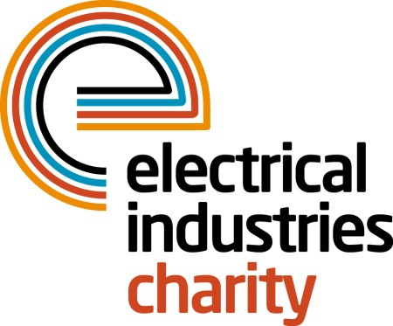
Press Release

14 March 2016

Financial support for apprentices

To celebrate National Apprenticeship Week, which takes place on 14-18 March, the Electrical Industries Charity has launched an Apprenticeship Bursary Scheme which is aimed at supporting apprentices working in the electrical or energy related industries who are struggling with family and financial commitments.

Young people who started their apprenticeship after 1 July 2015 and who are looking after a family or who are fulfilling the role of a primary carer can now apply for a bursary of £400 per month from the Charity. There are ten bursaries on offer with a total of £4,800 available for each of the 10 apprentices in a 12 month period.

The Bursary Scheme is part of the recently launched Apprentice Support Programme which is designed to help young people deal with some of the key challenges that affect them as they work towards their apprenticeship. The Programme offers independent advice and information through the Confidential Helpline on a wide variety of issues, such as rising debt and problems at home or work.

The Programme is supported by the Charity’s industry partner, City Electrical Factors (CEF). Charlie Beddows, Managing Director for CEF says: “We are delighted to be able to provide financial support for the Apprentice Support Programme. Apprentices are the lifeblood of the electrical industry and at times may need assistance to help them through the difficulties which they are facing in their lives.”

Tessa Ogle, Managing Director of the Electrical Industries Charity says: “More and more young people are now participating in apprenticeship programmes and the Charity needs to reflect this in the help which it offers to our industry. The Apprentice Support Programme and Bursary Scheme does just that and we are very pleased to be launching this with our industry partner, CEF as part of National Apprenticeship Week.”

For further information about the help on offer and to apply for a Bursary please contact the Confidential Helpline on: 0800 652 1618.

www.electricalcharity.org

Note to editors
The Electrical Industries Charity is the national charity for the electrical, electronics and energy industries. It aims to look after people from these industries whenever they or their families need help with life’s challenges.

The charitable services are available to anyone who currently works or has worked in the very diverse and often converging industries, such as:
- Electrical contracting and facilities management
- Electrical and electronic manufacturing, wholesale, distribution and retail
- Electrical and mechanical engineering
- Lighting industry
- Generation, distribution and supply of electrical power, including nuclear and renewable energy

For further information about the Electrical Industries Charity please contact Keystone Communications:

Tracey Rushton-Thorpe Monika Gaubyte
Tel: 01733 294524 Tel: 01733 294524
Email: tracey@keystonecomms.co.uk Email: monika@keystonecomms.co.uk

