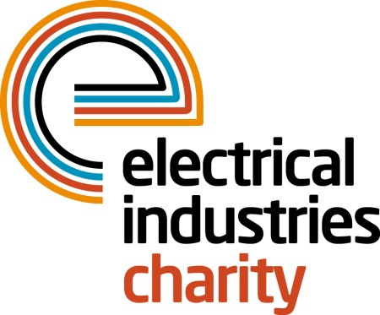
Press Release

23 March 2016

The Electrical Industries Charity is all set for the London Marathon

The Electrical Industries Charity is delighted to announce their ten runners for the Virgin Money London Marathon 2016.

The Virgin Money London Marathon is one of the biggest fundraising events in Great Britain bringing thousands of people together to raise money for different charities. This year the Electrical Industries Charity is proud to announce their ten runners who are all set to take on the 26 mile long challenge and raise money to help those in our industry who need it most.

The Charity’s runners who are taking part in this year’s Virgin Money London Marathon are; Joe Ellis from Edmundson Electrical Ltd; Alun Evans from Phase Electrical; Philip Woolley from Electrical Review; Scott Wildego from R&B Star; Zak Benney and Guy Powney from Edmundson Electrical’s Western Office; Daniel Mullinder, Paul Murphy, Mark Weston from Edmundson Electrical Carlisle and Juan Subira from Schneider Electric.

Show your support for the charity’s runners now and help them to make a difference in people’s lives by making a donation today.

Managing Director, Tessa Ogle says: “We would like to wish all of our runners the best of luck. The Virgin Money London Marathon is a fantastic way to raise money for those in our industry when they need it most, and we are thrilled to have so many people running for our charity this year. Last year our runners raised a massive £33,000, and we are looking forward to raising even more this year.

www.electricalcharity.org

For more information and to show your support to each runner visit the Electrical Industries Charity’s Facebook and Twitter pages:

Facebook- https://www.facebook.com/electricalcharity
Twitter- https://twitter.com/electriccharity

Note to editors
The Electrical Industries Charity is the national charity for the electrical, electronics and energy industries. It aims to look after people from these industries whenever they or their families need help with life’s challenges.

The charitable services are available to anyone who currently works or has worked in the very diverse and often converging industries, such as:
- Electrical contracting and facilities management
- Electrical and electronic manufacturing, wholesale, distribution and retail
- Electrical and mechanical engineering
- Lighting industry
- Generation, distribution and supply of electrical power, including nuclear and renewable energy

For further information about the Electrical Industries Charity please contact Keystone Communications:

Tracey Rushton-Thorpe Monika Gaubyte
Tel: 01733 294524 Tel: 01733 294524
Email: tracey@keystonecomms.co.uk Email: monika@keystonecomms.co.uk

