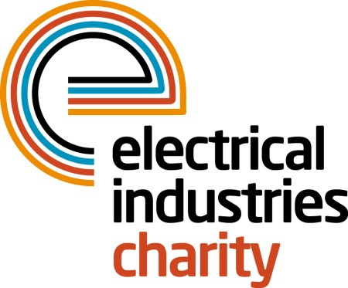
Press Release

02 March 2016

Showcase your business at the National Golf Championship 2016

Team up with the Electrical Industries Charity and compete among the best golfers in the industry at the National Golf Championship 2016. Sponsorship packages are now available so don’t miss a chance to showcase your business at the prestigious Belfry Hotel on Thursday 29 September 2016.

The 4 Ball competition will tee off at one of the most famous golfing locations in the UK the stunning championship Brabazon course which is surrounded by 500 acres of countryside, and the course boasts carpet-smooth greens and iconic holes where some of the most dramatic moments in the history of the sport have played out.

Become a sponsor now and gain publicity for your business by choosing the headline sponsorship which provides an incredible opportunity to put your company in the spotlight throughout the upcoming months. Other benefits of this great sponsorship package include two team entries of four into the National Golf Championship, welcome and on-course branding together with a full marketing package in the lead up to the event.

Those who are looking for alternative sponsorship opportunities can choose from other great packages available, such as Dinner Sponsorship at the cost of £2,000 or why not choose a Halfway House Sponsorship for just £1,000.

Haven’t booked your team yet? Don’t worry there is still time to secure your place at the 4 ball competition and play at the most exclusive course in the UK, for just £1,049 per team.

Managing Director, Tessa Ogle says: “The National Golf Championship is a fantastic event that attracts over a hundred golf enthusiasts each year. This event is also an excellent opportunity for industry professionals to gain exposure through a range of sponsorship packages and build business relationships in a relaxed atmosphere.”

For more details on tickets and sponsorship packages, please contact Liva Ivanova, telephone: 02036961716 email: liva.ivanova@electricalcharity.org

www.electricalcharity.org

Note to editors
The Electrical Industries Charity is the national charity for the electrical, electronics and energy industries. It aims to look after people from these industries whenever they or their families need help with life’s challenges.

The charitable services are available to anyone who currently works or has worked in the very diverse and often converging industries, such as:
- Electrical contracting and facilities management
- Electrical and electronic manufacturing, wholesale, distribution and retail
- Electrical and mechanical engineering
- Lighting industry
- Generation, distribution and supply of electrical power, including nuclear and renewable energy

For further information about the Electrical Industries Charity please contact Keystone Communications:

Tracey Rushton-Thorpe Monika Gaubyte
Tel: 01733 294524 Tel: 01733 294524
Email: tracey@keystonecomms.co.uk Email: monika@keystonecomms.co.uk

