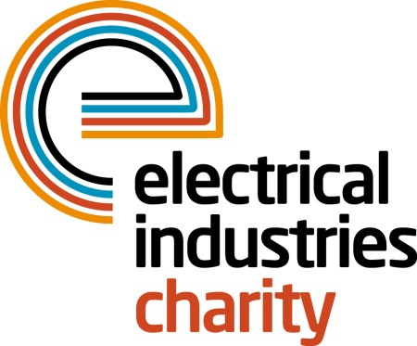
Press Release

16 March 2016

Put your senses into overdrive with a Charity Skydive

Imagine an experience that pushes you to the heights of your limits. One that has your heart racing, the adrenaline pumping and leaves you so ecstatic you want to scream out loud.

The Electrical Industries Charity is hosting the most thrilling, skydiving experience which is taking place on Saturday 16th July 2016 at the Go Skydive Centre, Old Sarum Park, Salisbury, Wiltshire. The Go Skydiving event will take your breath away as you freefall from 10,000ft at a speed of 125mph.

Are you feeling brave enough to push yourself to the boundaries? Sign up today and show your family, friends and colleagues how far you can go to raise money for those who need the help and support of our industry charity. The venue will have plenty of entertainment for your spectators too with free entry to the aviation museum and plenty of activities for kids throughout the day.

The Go Skydiving event is free, all you have to do is raise a donation of £500, so get your family and friends to help you to fundraise for this great cause and enjoy a fun day this summer.

Managing Director, Tessa Ogle says: “We are thrilled to be hosting such an exciting and breath-taking event. The skydive aims to raise money and give people an opportunity to try something new and challenging. We are looking forward to meeting those who are ready to face their fears at this fantastic summer event.”

For further details on the Go Skydiving event, visit www.electricalcharity.org

The Confidential Helpline number is: 0800 652 1618.

Note to editors
The Electrical Industries Charity is the national charity for the electrical, electronics and energy industries. It aims to look after people from these industries whenever they or their families need help with life’s challenges.

The charitable services are available to anyone who currently works or has worked in the very diverse and often converging industries, such as:
- Electrical contracting and facilities management
- Electrical and electronic manufacturing, wholesale, distribution and retail
- Electrical and mechanical engineering
- Lighting industry
- Generation, distribution and supply of electrical power, including nuclear and renewable energy

For further information about the Electrical Industries Charity please contact Keystone Communications:

Tracey Rushton-Thorpe Monika Gaubyte
Tel: 01733 294524 Tel: 01733 294524
Email: tracey@keystonecomms.co.uk Email: monika@keystonecomms.co.uk

