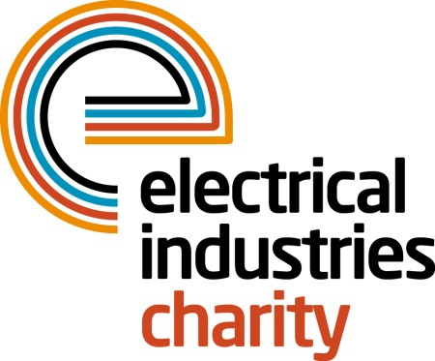
Press Release

18 April 2016

Challenge the Dragon

The Electrical Industries Charity’s first ever Dragon Boat 2016 is fast approaching and what better way to spend some time with your family, friends and colleagues than by signing your team up for the fastest growing water activity in Britain.

Dragon Boat 2016 takes place at the picturesque Peterborough rowing lake on Saturday 06 August 2016. This exciting summer event will offer great entertainment for everyone and make a perfect family day out this summer.

This fun-filled event will allow industry professionals to re-ignite their team spirit and compete against their rivals while having fun with their families, friends, and colleagues. Families can also look forward to a fun day out with plenty of entertainment to choose from including a funfair with children’s rides and stalls.

Managing Director, Tessa Ogle says: “We are very excited to host our first ever Dragon Boat event this summer that will bring our industry professionals and their families and friends together. We believe that spending time with family is crucial for everyone, and what better way to do this than by joining us at our fantastic summer event.”

What are you waiting for- sign your team up today for as little as £1000. For more information contact, Vicky Gray: vicky.gray@electricalcharity.org

www.electricalcharity.org

Note to editors
The Electrical Industries Charity is the national charity for the electrical, electronics and energy industries. It aims to look after people from these industries whenever they or their families need help with life’s challenges.

The charitable services are available to anyone who currently works or has worked in the very diverse and often converging industries, such as:
- Electrical contracting and facilities management
- Electrical and electronic manufacturing, wholesale, distribution and retail
- Electrical and mechanical engineering
- Lighting industry
- Generation, distribution and supply of electrical power, including nuclear and renewable energy

For further information about the Electrical Industries Charity please contact Keystone Communications:

Tracey Rushton-Thorpe Monika Gaubyte
Tel: 01733 294524 Tel: 01733 294524
Email: tracey@keystonecomms.co.uk Email: monika@keystonecomms.co.uk

