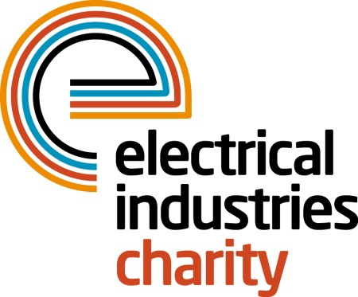

Press Release

25 April 2016

Help to build a future by climbing Mount Kilimanjaro

The Electrical Industries Charity is set for a Kilimanjaro challenge which aims to raise £100,000 to help the Hendrie family to re-build their lives.

Christopher Hendrie, aged 32 was a well-respected electrician, a loving husband and a father of two who lost his fight to the rare form of Cholangiocarcinoma cancer which is commonly known as Bile duct cancer on 31 October 2014.

The Hendrie family’s life changed within the period of ten days. On 25 August 2014 Christopher and his wife Gillian found out that they were expecting their third child, but their happiness was short-lived as ten days later Christopher was diagnosed with an extremely rare form of cancer. Nine weeks later after having intensive radiation and chemotherapy treatments, Christopher sadly passed away on 31 October 2014, with his wife by his side and without seeing the birth of his third child.

Christopher was not eligible for a life insurance due to his existing genetic autoimmune disease, and his family has been left with nowhere to turn. To help lift this heavy burden and to build a future for the family, the Electrical Industries Charity has set the Mount Kilimanjaro fundraising challenge and is hoping to raise £100,000 by February 2017.

The charity is now looking for 25 enthusiastic, passionate and fit trekkers to embark on their largest fundraising challenge between 03-14 February 2017 to support research into a rare form of cancer and give financial assistance to the Hendrie family.

Managing Director, Tessa Ogle says: “This rare cancer has taken away a father and a husband from the Hendrie family within such a short period. We are honoured to take on this remarkable challenge and look forward to raising this huge amount which will help to re-build the Hendrie family’s future.”

Christopher’s life changed in ten days, you have the power to change his family’s life in 10 days too. Sign up today and climb the tallest free-standing mountain in the world with a height of 5895m.

For further details, or to participate visit,

www.electricalcharity.org

Note to editors
The Electrical Industries Charity is the national charity for the electrical, electronics and energy industries. It aims to look after people from these industries whenever they or their families need help with life’s challenges.

The charitable services are available to anyone who currently works or has worked in the very diverse and often converging industries, such as:
- Electrical contracting and facilities management
- Electrical and electronic manufacturing, wholesale, distribution and retail
- Electrical and mechanical engineering
- Lighting industry
- Generation, distribution and supply of electrical power, including nuclear and renewable energy

For further information about the Electrical Industries Charity please contact Keystone Communications:

Tracey Rushton-Thorpe Monika Gaubyte
Tel: 01733 294524 Tel: 01733 294524
Email: tracey@keystonecomms.co.uk Email: monika@keystonecomms.co.uk

