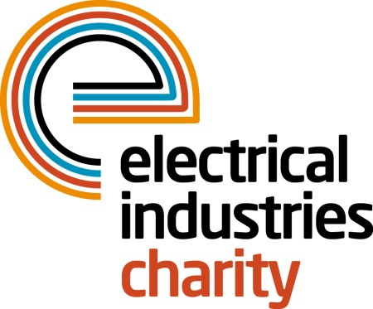
Press Release

02 May 2016

Charity team head for new heights

The Rexel Banners team are taking on the mighty and adventurous 24 hour Three Peaks Challenge to raise money for the Electrical Industries Charity. The team facing this immense challenge will consist of representatives from Newey & Eyre, WF Senate, Wilts Electrical Wholesale and Timeguard.

The 24-hour Challenge will take place on 09 July 2016, and will see the team scale the tallest peaks in Scotland, Wales, and England including Ben Nevis, Scafell Pike, and Snowdon. The Challenge was organised by Neil Chapman and Dean Shorten from Timeguard with the aim to raise awareness and money for the Electrical Industries Charity while completing the challenge within 24 hours which will include the 270 miles drive between Peaks.

The team includes: Colin Dance; Gavin Tallentire, Richard Wilson; Peter Shields; Chris Morley; Andy Stone; Ricky Trott and Dean Shorten. It will be led by Neil Chapman, Sales Manager from Timeguard, who has previously completed this challenge for the Electrical Industries Charity in 2011.

The team has already started their training which consists of cross training and hill climbing which will allow them to strengthen their muscles and be fully prepared for the challenge of the year.

Sales Manager, Neil Chapman from Timeguard, says: “We’ve teamed up with many representatives from our industry for the Three Peaks Challenge to raise awareness of the great work and support that our charity gives to people in our industry who need help the most.”

Managing Director, Tessa Ogle says: “We are delighted that so many representatives from our industry decided to join the 24 hour Three Peaks Challenge to support our charity. We would like to wish good luck to the Rexel Banners team in completing this tough challenge this summer.”

www.electricalcharity.org

Note to editors
The Electrical Industries Charity is the national charity for the electrical, electronics and energy industries. It aims to look after people from these industries whenever they or their families need help with life’s challenges.

The charitable services are available to anyone who currently works or has worked in the very diverse and often converging industries, such as:
- Electrical contracting and facilities management
- Electrical and electronic manufacturing, wholesale, distribution and retail
- Electrical and mechanical engineering
- Lighting industry
- Generation, distribution and supply of electrical power, including nuclear and renewable energy

For further information about the Electrical Industries Charity please contact Keystone Communications:

Tracey Rushton-Thorpe Monika Gaubyte
Tel: 01733 294524 Tel: 01733 294524
Email: tracey@keystonecomms.co.uk Email: monika@keystonecomms.co.uk

