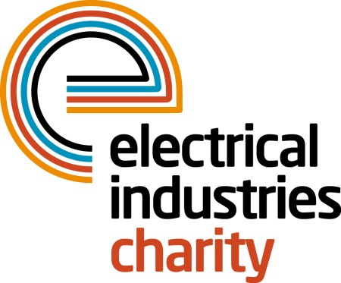
Press Release

16 May 2016

The EW Awards 2016 is a huge success for the Electrical Industries Charity

The Electrical Wholesaler Awards 2016 raised a huge amount to help the Electrical Industries Charity to continue supporting people who need help the most.

The Electrical Wholesaler Awards 2016 took place at the Park Plaza, London on Thursday 12 May 2016 and raised a massive £1,835 to support the Electrical Industries Charity. The charity will dedicate this money to help the Hendrie family to rebuild their lives after a sad loss of a loving husband and a father of three who lost his life to an extremely rare form of Cholangiocarcinoma cancer which is commonly known as Bile duct cancer.

Managing Director, Tessa Ogle says: “I would like to say a huge thank you to Electrical Wholesaler for their continuous support and such a great amount raised.”

“The EW Awards 2016 was a fantastic event that raised much-needed funds for our charity. We are delighted for such a significant amount which will be given to help the Hendrie family to rebuild their future.”

www.electricalcharity.org

Note to editors
The Electrical Industries Charity is the national charity for the electrical, electronics and energy industries. It aims to look after people from these industries whenever they or their families need help with life’s challenges.

The charitable services are available to anyone who currently works or has worked in the very diverse and often converging industries, such as:
- Electrical contracting and facilities management
- Electrical and electronic manufacturing, wholesale, distribution and retail
- Electrical and mechanical engineering
- Lighting industry
- Generation, distribution and supply of electrical power, including nuclear and renewable energy

For further information about the Electrical Industries Charity please contact Keystone Communications:

Tracey Rushton-Thorpe Monika Gaubyte
Tel: 01733 294524 Tel: 01733 294524
Email: tracey@keystonecomms.co.uk Email: monika@keystonecomms.co.uk

