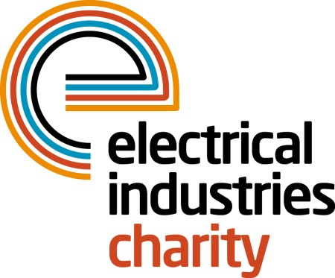
Press Release

09 May 2016

Marathon runners are a huge success

The Virgin Money London Marathon proved to be a great success for the Electrical Industries Charity with charity runners raising over £11,000.

The London Marathon remains one of the biggest charity fundraising events in the UK and this year the Electrical Industries Charity had nine runners completing the gruelling 26-mile course. The nine Charity’s runners who took part in this year’s Virgin Money London Marathon were; Joe Ellis from Edmundson Electrical Ltd; Alun Evans from Phase Electrical; Philip Woolley from Electrical Review; Scott Wildego from R&B Star; Zak Benney and Guy Powney from Edmundson Electrical’s Western Office; Daniel Mullinder, Paul Murphy, Mark Weston from Edmundson Electrical Carlisle and Juan Subira from Schneider Electric.

Managing Director, Tessa Ogle says: “I would like to say a huge thank you to everyone who took part in the Virgin Money London Marathon on behalf of the Electrical Industries Charity. Their efforts have inspired so many people in our industry to take part in next years The Virgin Money London Marathon as well as raising such a great amount which will help us to continue to provide support to people in our industry who need help the most.”

“We have already had enquiries about places for the 2017 event and I can confirm that we will once again be offering Gold Bond places to those who would like to take part and raise funds for the Electrical Industries Charity. But it is worth remembering that if you do get a ballot place for 2017 you can still raise funds for the charity and help us to support those in our industry when they need it most.”

For further information and to apply for a 2017 Virgin Money London Marathon place please contact Vicky Gray, email: vicky.gray@electricalcharity.org

www.electricalcharity.org

Photo caption- Paul Murphy of Edmundson Electrical Carlisle.

Note to editors
The Electrical Industries Charity is the national charity for the electrical, electronics and energy industries. It aims to look after people from these industries whenever they or their families need help with life’s challenges.

The charitable services are available to anyone who currently works or has worked in the very diverse and often converging industries, such as:
- Electrical contracting and facilities management
- Electrical and electronic manufacturing, wholesale, distribution and retail
- Electrical and mechanical engineering
- Lighting industry
- Generation, distribution and supply of electrical power, including nuclear and renewable energy

For further information about the Electrical Industries Charity please contact Keystone Communications:

Tracey Rushton-Thorpe
Tel: 07753 840386
Email: tracey@keystonecomms.co.uk

