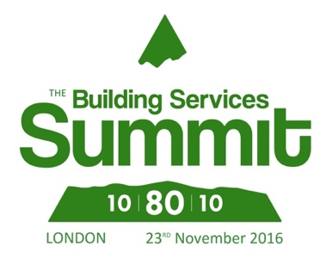

Press release for immediate release

Date : 16th May, 2016

Celebrity engineer Kate Bellingham to chair Building Services Summit 2016

Former BBC presenter and engineer Kate Bellingham is to host a series of panel discussions at this year’s Building Services Summit. Kate is one of the UK’s best-known engineers and a passionate communicator about the importance of the industry.

Following a four-year spell on the BBC’s flagship science programme Tomorrow’s World, Kate has spent considerable time pushing for the greater involvement of women in engineering. In 2011, she won an outstanding achievement award for her campaigning and charitable efforts on this issue.

The Building Services Summit 2016 is being jointly organised by the Building Controls Industry Association (BCIA); Building Engineering Services Association (BESA); and the Electrical Contractors’ Association (ECA).

The Summit will focus on how the construction sector can deliver buildings that operate more effectively and efficiently in the long-term. Presentations from government, research bodies and building managers will be supported by panel discussions – with the aim of creating a collaborative event that will be informative as well as exciting.

It’s a unique approach to organising an event and other bodies including the Federation of Environmental Trade Associations (FETA) are also lending their support.

Confirmed speakers for the event include senior civil servant Roy Evans of the Cabinet Office who will be presenting on the Government’s Soft Landings programme; and Paul Kavern of the British Library, who will be offering a view on how the Library has faced its challenges as a building.

Tomas De Staic, a senior policy advisor on energy efficiency for the Department for Energy and Climate Change (DECC), will also be presenting on managing the public sector real estate in an energy efficient way.

The discussion sessions will allow delegates to ask questions of panelists and also to identify common ground for making improvements in construction practice. Topics that will be discussed by speakers, panelists and the audience include:

* How can we move away from retentions?
* Do building regulations stifle innovation?
* What are the alternatives to the current processes of construction?
* Can better training help alleviate problems?

The Building Services Summit is being held at the British Library on 23rd November. For full details of the Building Services Summit and to book your place for only £30, please go to www.buildingservicessummit.co.uk.

Information for Editors
The Building Services Summit is jointly funded and organised by the BCIA, BESA and ECA with support from FETA. Full details can be found on www.buildingservicessummit.co.uk. For queries on this press release please contact Karen Fletcher at Keystone Communications: karen@keystonecomms.co.uk 01733 284 524

