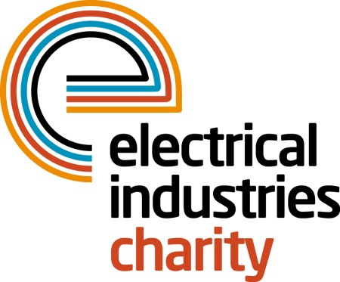
Press Release

06 June 2016

Get active this summer with the Electrical Industries Charity

It’s time to get active this summer with the Electrical Industries Charity who have lots of sports events to get involved with.

The Electrical Industries Charity is offering a number of unmissable events which will push you to the limits and get your heart racing while getting fit and having loads of fun with friends, family and colleagues.

At the Color Vibe, YOU are our color canvas, and when you’re finished with this 5k run you’ll be an exciting and vivid masterpiece. Sign up to the coolest color blast 5K run to hit the streets and get fundraising. The Color Vibe 5k run takes place from 9th July until 20th August in Bristol, East Sussex, London, Edinburgh and Essex.

Or why not put your senses into overdrive and get your heart racing at the charity’s Skydive which is taking place on 16th July at the Go Sky Dive Centre, Wiltshire. This will take your breath away as you freefall from 10,000ft at a speed of 125mph.

Want to challenge your industry rivals and enjoy the sunshine with your family, friends and colleagues? Challenge the Dragon is the charity’s first ever Dragon Boat event taking place on 6th August at the Rowing Lake, Peterborough. A great team challenge and plenty for all the family including funfair rides and face painting for children.

Do you have the strength and ability to combat extreme mental and physical challenges? The Mudnificent 7 is the UK's Obstacle Course and best muddy event this summer! This takes place on 13th August at the Heart Park, Warwickshire.

Managing Director, Tessa Ogle says: “This summer we are delighted to bring so many great events that will challenge people in our industry while allowing them to enjoy the summer sunshine and get fundraising.”

Our all active sports events this year are a brilliant way to take part and get involved with supporting the Electrical Industries Charity through sponsorship from colleagues, friends and family. Sign up today by visiting the events page of our website!

http://www.electricalcharity.org/index.php/fundraising-events

For more information, contact, Vicky Gray: vicky.gray@electricalcharity.org
Note to editors
The Electrical Industries Charity is the national charity for the electrical, electronics and energy industries. It aims to look after people from these industries whenever they or their families need help with life’s challenges.

The charitable services are available to anyone who currently works or has worked in the very diverse and often converging industries, such as:
- Electrical contracting and facilities management
- Electrical and electronic manufacturing, wholesale, distribution and retail
- Electrical and mechanical engineering
- Lighting industry
- Generation, distribution and supply of electrical power, including nuclear and renewable energy

For further information about the Electrical Industries Charity please contact Keystone Communications:

Tracey Rushton-Thorpe Monika Gaubyte
Tel: 01733 294524 Tel: 01733 294524
Email: tracey@keystonecomms.co.uk Email: monika@keystonecomms.co.uk

