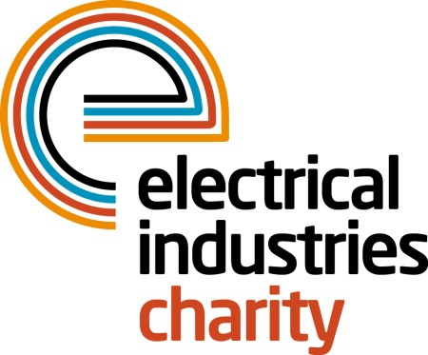
Press Release

20 June 2016

Get together for the National Golf Championship 2016

The most anticipated National Golf Championship of the year in the electrical industry is fast approaching. Don’t miss your chance to compete among the best golfers in the industry and showcase your business with sponsorship packages available.

Teams who have already signed up include: Schneider Electric; Edmundson Electrical, City Electrical Factors (CEF), Calon Energy, GDC Group, National Nuclear Laboratory; and Wilts Electrical Wholesalers. Now it’s time for you to sign up too.

The 4 Ball competition is taking place on Thursday 29 September 2016 at one of the most iconic golfing locations in the UK-the stunning championship Brabazon course which is surrounded by 500 acres of countryside.

Gain publicity for your business by choosing from one of the available sponsorship packages; Dinner Sponsorship, Halfway House sponsorship or Golf Ball Sponsorship. Or why not sign up a team of four for only £1,049 which includes breakfast at registration, goodie bags, a day on the famous Brabazon Course followed by a drinks reception, three-course dinner and entertainment in the evening.

Managing Director, Tessa Ogle says: “Golf continues to be one of the UK’s most popular corporate sports and provides a perfect opportunity for building business relationships in a relaxed environment away from the office while playing among the best golfers in the industry. With only three months left until one of the most prestigious golfing events in our industry now it is the perfect time for businesses to book their place and help to raise funds for those who need help most.”

Secure your place today and don’t miss the opportunity to be at the best golfing event this year. For further details on sponsorship packages or to book your place, please contact, Vicky Gray: vicky.gray@electricalcharity.org

www.electricalcharity.org

Note to editors
The Electrical Industries Charity is the national charity for the electrical, electronics and energy industries. It aims to look after people from these industries whenever they or their families need help with life’s challenges.

The charitable services are available to anyone who currently works or has worked in the very diverse and often converging industries, such as:
- Electrical contracting and facilities management
- Electrical and electronic manufacturing, wholesale, distribution and retail
- Electrical and mechanical engineering
- Lighting industry
- Generation, distribution and supply of electrical power, including nuclear and renewable energy

For further information about the Electrical Industries Charity please contact Keystone Communications:

Tracey Rushton-Thorpe Monika Gaubyte
Tel: 01733 294524 Tel: 01733 294524
Email: tracey@keystonecomms.co.uk Email: monika@keystonecomms.co.uk

