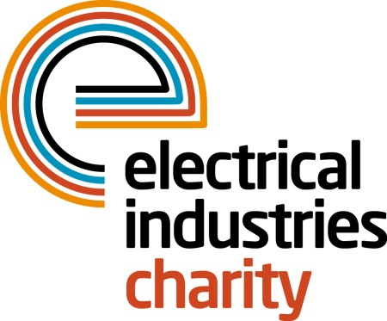

Press Release

20 July 2016

Team up for the National Golf Championship 2016

The Electrical Industries Charity’s National Golf Championship 2016 is only one month away. Don’t miss your opportunity to book your team for the best golfing event in the electrical industry. Last few places remain. Sign up today.

The 4 Ball competition is taking place on Thursday 29 September 2016 at one of the most iconic golfing locations in the UK-the beautiful Brabazon course which is surrounded by 500 acres of countryside.

Teams who have already signed up and are ready to compete among the best golfers include City Electrical Factors (CEF); Schneider; Calon Energy; Wilts Electrical Wholesalers; Dimplex; Edmundson Electrical Twickenham and National Nuclear Laboratory.

Want to stand out from the crowd and gain publicity for your business? Choose from one of the sponsorship packages available including; Dinner Sponsorship, Halfway House sponsorship or Golf Ball Sponsorship. Secure your place for this fantastic event today with the summer special reduced price tickets for just £989. These include breakfast at registration, goodie bags, a day on the famous Brabazon Course followed by a drinks reception, three-course dinner and entertainment in the evening.

Managing Director, Tessa Ogle says: “The National Golf Championship is a fantastic opportunity to network with the largest names in the industry at the world-class resort while having a fun day away from the office and raising funds for those who need help most.”

Places are limited. Don’t wait until it’s too late. Sign up for a golfing challenge today and show your support for your industry’s charity. For further information, please contact Vicky Gray: vicky.gray@electricalcharity.org

www.electricalcharity.org

Note to editors
The Electrical Industries Charity is the national charity for the electrical, electronics and energy industries. It aims to look after people from these industries whenever they or their families need help with life’s challenges.

The charitable services are available to anyone who currently works or has worked in the very diverse and often converging industries, such as:
- Electrical contracting and facilities management
- Electrical and electronic manufacturing, wholesale, distribution and retail
- Electrical and mechanical engineering
- Lighting industry
- Generation, distribution and supply of electrical power, including nuclear and renewable energy

For further information about the Electrical Industries Charity please contact Keystone Communications:

Tracey Rushton-Thorpe Monika Gaubyte
Tel: 01733 294524 Tel: 01733 294524
Email: tracey@keystonecomms.co.uk Email: monika@keystonecomms.co.uk

