Press Release

07 July 2016

New President for the British Refrigeration Association

John Smith, Group Technical Director for Beijer Ref UK & Ireland, has taken over the role of President of the British Refrigeration Association.

John succeeds Mike Lawrence – a stalwart of the BRA - who has held the position since 2014. Trade Associations rely on individuals volunteering to take on such roles, supported by their companies, and Mike has epitomised this in his years of service with the BRA. The handover took place at the recent FETA Strategy Forum, held in Marlow.

John has been in the RAC industry for over 30 years in a variety of technical sales roles, and has been an active member within the BRA. He is currently chairman of the Equipment and Components section, and has been Vice President since 2015.

John commented: “I would like to pay tribute to the sterling work Mike has done for the BRA in his time as President, and I look forward to taking on the role in what will be challenging times for our industry.”

www.feta.co.uk/associations/bra

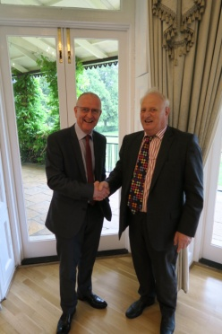 Mike Lawrence (r) hands over to John Smith (l)

Note to editors
The British Refrigeration Association (B.R.A.) is the only trade association representing manufacturers, importers, wholesalers, distributors, contractors, specifiers and end-users of refrigeration plant, equipment and components.
It also includes producers of refrigerants and lubricants, colleges and training establishments. It works closely with government, public bodies and other organisations, both in the UK and overseas, to further the interests of the refrigeration industry. BRA was originally formed in 1940 under the name "Commercial Electric Refrigeration Association". It has worked continuously since 1940, as C.E.R.A., B.R.A., B.R.A.C.A and now again B.R.A. to promote the interests of the Refrigeration Industry.

For further information about BRA please contact Keystone Communications:

Tracey Rushton-Thorpe Alex Shears
Tel: 01733 294524 Tel: 01733 294524
Email: tracey@keystonecomms.co.uk Email: alex@keystonecomms.co.uk

