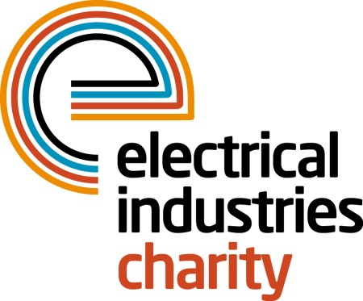
Press Release

25 July 2016

Set yourself to a new challenge in 2017

The Electrical Industries Charity is delighted to announce that they are now accepting applications for the Virgin Money London Marathon, which takes place on 23 April 2017. Register today and secure your place in one of the largest fundraising events on the planet. Hurry applications are closing soon.

The London Marathon remains one of the biggest charity fundraising events in the UK, and the Charity is urging members of the industry to take part in this iconic event and raise much-needed funds to help those in our industry when they need it most.

The Virgin Money London Marathon has received over 253,000 applications for the 2017 event. It is time for you to do the same and join them at this historic sporting event. Don’t wait until it is too late to do something incredible next year. The deadline for applications is on Thursday 1 September 2016. All applicants will be notified if they are successful by 31 October 2016.

Managing Director, Tessa Ogle says: “The Virgin Money London Marathon is one of the most famous races in the world that receives thousands of participants each year who are challenging their personal abilities to raise money for those who matter to them the most. In the past two years, the charity’s runners took to the streets of London and raised thousands of pounds for the Electrical Industries Charity. We are hoping to raise even more money in the upcoming year.

“Now is your opportunity to challenge yourself and to show your support for your charity by securing your place and raising money for those who need your help the most.”

Book your place today. For further information regarding the minimum donation or to register for a Virgin Money London Marathon place, please contact Vicky Gray email: vicky.gray@electricalcharity.org

www.electricalcharity.org

Note to editors
The Electrical Industries Charity is the national charity for the electrical, electronics and energy industries. It aims to look after people from these industries whenever they or their families need help with life’s challenges.

The charitable services are available to anyone who currently works or has worked in the very diverse and often converging industries, such as:
- Electrical contracting and facilities management
- Electrical and electronic manufacturing, wholesale, distribution and retail
- Electrical and mechanical engineering
- Lighting industry
- Generation, distribution and supply of electrical power, including nuclear and renewable energy

For further information about the Electrical Industries Charity please contact Keystone Communications:

Tracey Rushton-Thorpe
Tel: 07753 840386
Email: tracey@keystonecomms.co.uk

