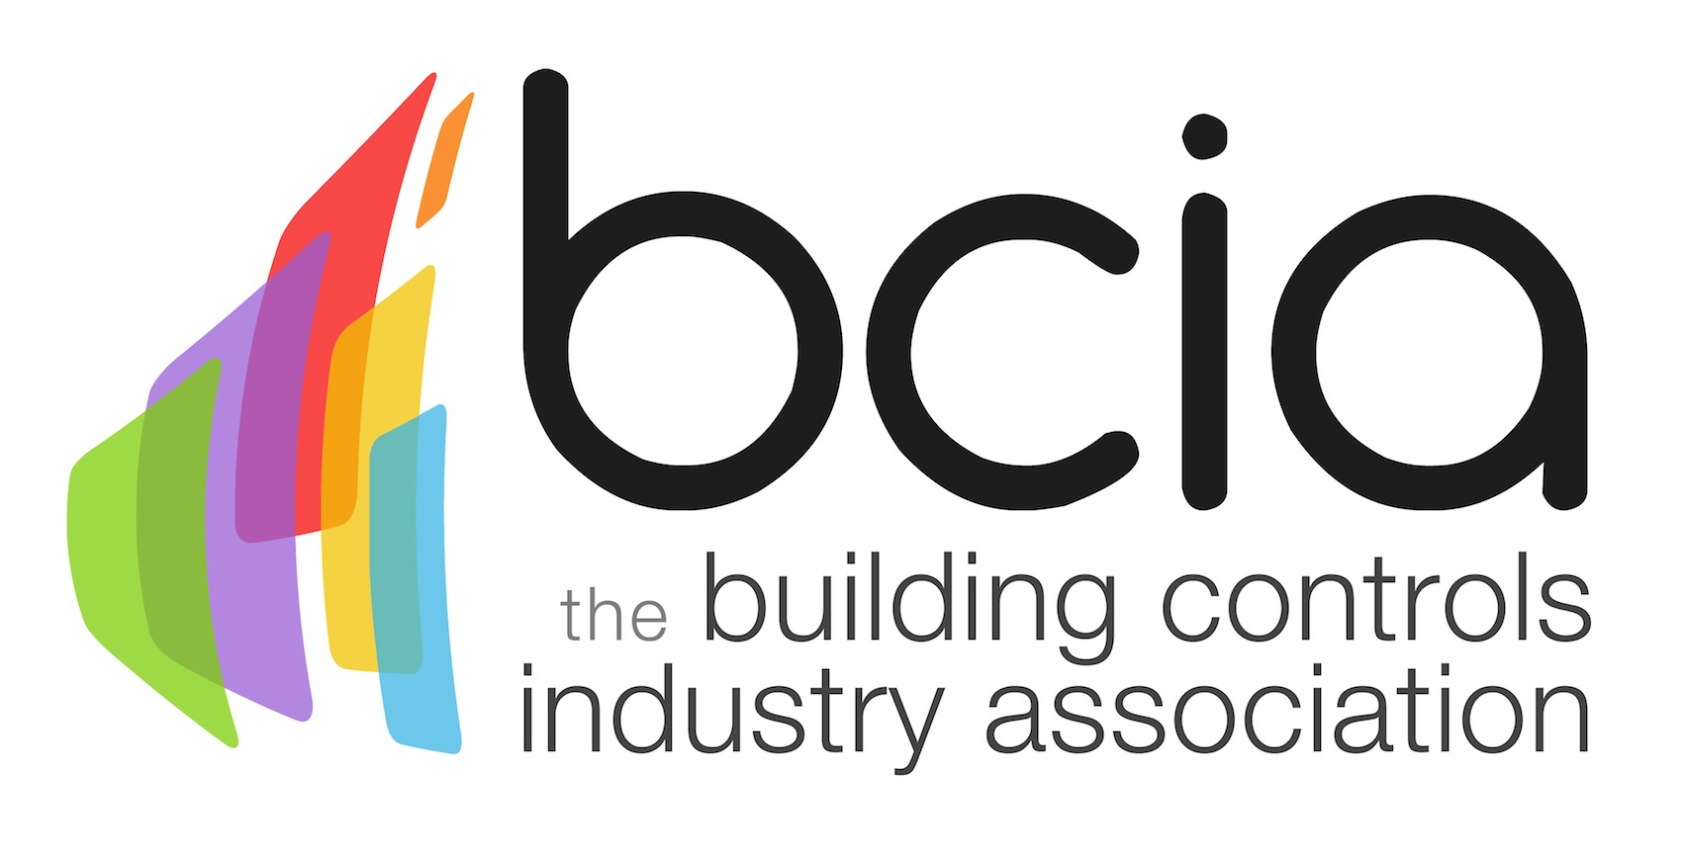

Press Release

04 July 2016

Lee Coffin takes over as Chairman of the Marketing Working Group

Lee Coffin has been appointed as the Chairman of the Marketing Working Group for the Building Controls Industry Association (BCIA).

Lee is Chief Operating Officer for Western Automation, a national technical distributor of major brand HVAC control products.

Lee says: “I look forward to steering the Marketing Group and overseeing how the BCIA presents itself to the outside world and its members. The BCIA continues to be crucial to the development of our industry and I’m delighted to be involved in the promotion of this active and lively association.”

The Marketing Working Group focuses on raising the profile of the Association and its members, along with building key industry relationships that benefit the sector.

The BCIA promotes better understanding, application and use of building controls. Working Groups within the Association are key to educating the industry.

www.bcia.co.uk

Note to editors
The Building Controls Industry Association (BCIA) represents the UK building controls and BEMS sector. With around 75 members accounting for 70% of the UK controls market, the BCIA is an influential group that promotes better specification, application and use of controls. The BCIA also offers its own training courses and the Building Controls Professional Assessment (BCPA).

For further information about the BCIA please contact Keystone Communications:

Alex Shears
Tel: 01733294524
Email: alex@keystonecomms.co.uk

