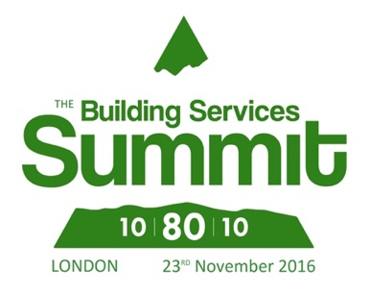
Press Release

09 August 2016

The Building Services Summit 2016 announces new speakers

New speakers have been announced for the Building Services Summit 2016 which has been launched by three leading industry services trade associations. The Building Controls Industry Association (BCIA), Building Engineering Services Association (BESA) and Electrical Contractors Association (ECA).

The Building Services Summit is taking place on 23rd November 2016, at the British Library, London. The conference organised by BCIA, BESA and ECA members will give everyone an opportunity to share ideas by taking part in lively and informative discussions.

The speakers will include Roy Evans, of the Cabinet Office who leads on Government Soft Landings (GSL) which is an objective of the Governments 2016-2020 Construction Strategy. Roy will be joined by Dr Karon Buck, founding principal of Medway UTC, a new school for 14-19-year-old students from Medway and the surrounding regions. Dr Susan Scurlock is also joining the speakers’ panel. Susan founded primary engineer in response to the government’s call for more young people to be attracted into the engineering profession in 2005.

Other industry experts who will be joining the discussion include Bill Wright of ECA who is an independent consultant on energy, control and sustainability matters. Graham Wright, legislation specialist of Daikin and President of FETA. Graham is a mechanical engineer who has worked in the air conditioning industry for over 30 years. David Frise, Head of Sustainability for BESA, and Stephen Hill an associate and building performance engineer for Arup are also part of the discussion panel.

The most anticipated event of the year 10-80-10 Summit will be discussing topical questions including:

- Is the process of construction broken?
- Do building regulations stifle innovation?
- Why aren’t clients using the technological tools that are available?
- What are the alternatives to the current process of construction?

Malcolm Anson, President of the BCIA, says: “We have assembled some of the world’s most qualified experts to speak about how building engineering services can operate as efficiently and effectively to reshape the future of our buildings.”

“The leading industry experts will discuss the most topical questions in the construction sector and will address the challenges of a long-term building efficiency. The discussion will help the building owners and facilities managers to understand where efficiencies can be made in both new and existing buildings.”

Be ahead of the game and join us for this unmissable event for just £36. Book your ticket today to secure your place. For further details, visit: www.buildingservicessummit.co.uk

Note to editors
The Building Controls Industry Association (BCIA) represents the UK building controls and BEMS sector. With around 75 members accounting for 70% of the UK controls market, the BCIA is an influential group that promotes better specification, application and use of controls. The BCIA also offers its own training courses and the Building Controls Professional Assessment (BCPA).

For further information about the BCIA please contact Keystone Communications:

Karen Fletcher
Tel: 01733 284 524
Email: karen@keystonecomms.co.uk

