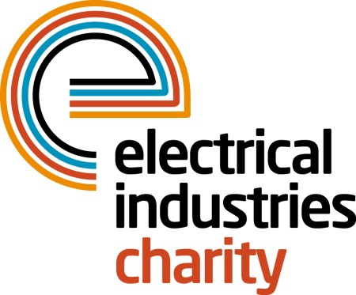
Press Release

02 August 2016

Are you ready for the Zombie Invasion?

Do you have what it takes to survive the Zombie Apocalypse? The Electrical Industries Charity is looking for brave, enthusiastic and fit runners to participate in a 5k Zombie Evacuation Run to save the Allianz Park from the Zombie Invasion this Halloween.

The Zombie Evacuation Race is taking place on Monday 31 October 2016 at the Allianz Park, London. The race promises to give you a number one experience you will never forget.

The charity is offering a choice of two races including the Apocalypse at Alliance Park and the Dusk ‘Till Dawn Race that will leave you running for your life through a 5k course while navigating through a multitude of challenging obstacles.

The Apocalypse at Allianz Park will give you an opportunity to save the park from infected Zombies who are planning to scare and infect the inhabitants of the park. Your aim is to prevent those merciless zombies from biting you three times, outrun the Zombie hoards and dodge the undead to save the park.

A new terrifying breed of the undead has also been witnessed in the woods surrounding the Allianz Park, who are descending on the stadium after dusk. You have an opportunity to see those terrifying new creatures who haunt the arena and help the RAZOR team to fight this new danger that threatens to take down the stadium.

Are you ready to save the stadium? Challenge yourself at the Dusk ‘Till Dawn and test your courage, endurance and survival abilities by being the last one standing to win a £200 reward.

Managing Director, Tessa Ogle says: “The 5k Zombie Evacuation Race is a fun experience that will leave you with unforgettable memories. Participants in the race will be able to experience running in a different atmosphere which will challenge their ability to overcome their biggest fears and will test their endurance while raising money for those who need help most.”

Do you think you can dodge the undead? Sign up with friends and colleagues today and take a team challenge of a lifetime. For more information, visit: www.electricalcharity.org

Note to editors
The Electrical Industries Charity is the national charity for the electrical, electronics and energy industries. It aims to look after people from these industries whenever they or their families need help with life’s challenges.

The charitable services are available to anyone who currently works or has worked in the very diverse and often converging industries, such as:
- Electrical contracting and facilities management
- Electrical and electronic manufacturing, wholesale, distribution and retail
- Electrical and mechanical engineering
- Lighting industry
- Generation, distribution and supply of electrical power, including nuclear and renewable energy

For further information about the Electrical Industries Charity please contact Keystone Communications:

Tracey Rushton-Thorpe Monika Gaubyte
Tel: 01733 294524 Tel: 01733 294524
Email: tracey@keystonecomms.co.uk Email: monika@keystonecomms.co.uk

