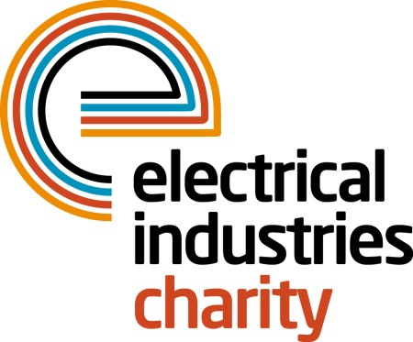
Press Release

12 September 2016

Creating a better future with the Electrical Industries Charity

The Electrical Industries Charity has launched its Practical Participation Programme to expand the support network and allow electrical industry professionals to show their support to people who need help the most.

The Practical Participation Programme offers an opportunity for companies to get involved using their unique skills of time, equipment and materials to provide the best practical support to people in the electrical industry.

The programme was created by the charity to get everyone within the electrical industry involved in offering practical support to those who are struggling. It will also allow industry experts to work alongside the charity in solving, or contributing to solutions, for those desperately needing help.

Once you sign up to be a partner of the programme the charity will approach you on an as-needed basis to ask for your assistance. As a partner of the charity, you will be making a significant contribution to improving lives of retired colleagues, apprentices, employees and their families. Because the purpose of this programme is helping people, not making a profit, the charity can boost your business’s reputation for corporate social responsibility.

Some of the charity’s clients have insufficient heating; or issues with electrical or energy systems, thermostats and essential appliance fittings. Their complex case management often involves small-scale building rectification or modification works, often related to disability access and in particular circumstances, the charity also takes on fundraising challenges for a specific cause. Your practical assistance can go a long way to delivering long-lasting, large-scale solutions so why not show your support for people in your industry by contributing to those much-needed solutions.

Managing Director, Tessa Ogle says: “We launched the Practical Participation Programme to get everyone within the electrical sector involved in supporting people through challenging times in their lives. This programme is an excellent opportunity for companies to work alongside the charity in helping to create a pathway to a better future for people in our industry.”

Don’t let people in your industry struggle on their own. Sign up to the Practical Participation Programme today and make a difference in someone’s life.

For further information, please contact Vicky Gray: vicky.gray@electricalcharity.org

www.electricalcharity.org

Note to editors
The Electrical Industries Charity is the national charity for the electrical, electronics and energy industries. It aims to look after people from these industries whenever they or their families need help with life’s challenges.

The charitable services are available to anyone who currently works or has worked in the very diverse and often converging industries, such as:
- Electrical contracting and facilities management
- Electrical and electronic manufacturing, wholesale, distribution and retail
- Electrical and mechanical engineering
- Lighting industry
- Generation, distribution and supply of electrical power, including nuclear and renewable energy

For further information about the Electrical Industries Charity please contact Keystone Communications:

Tracey Rushton-Thorpe Monika Gaubyte
Tel: 01733 294524 Tel: 01733 294524
Email: tracey@keystonecomms.co.uk Email: monika@keystonecomms.co.uk

