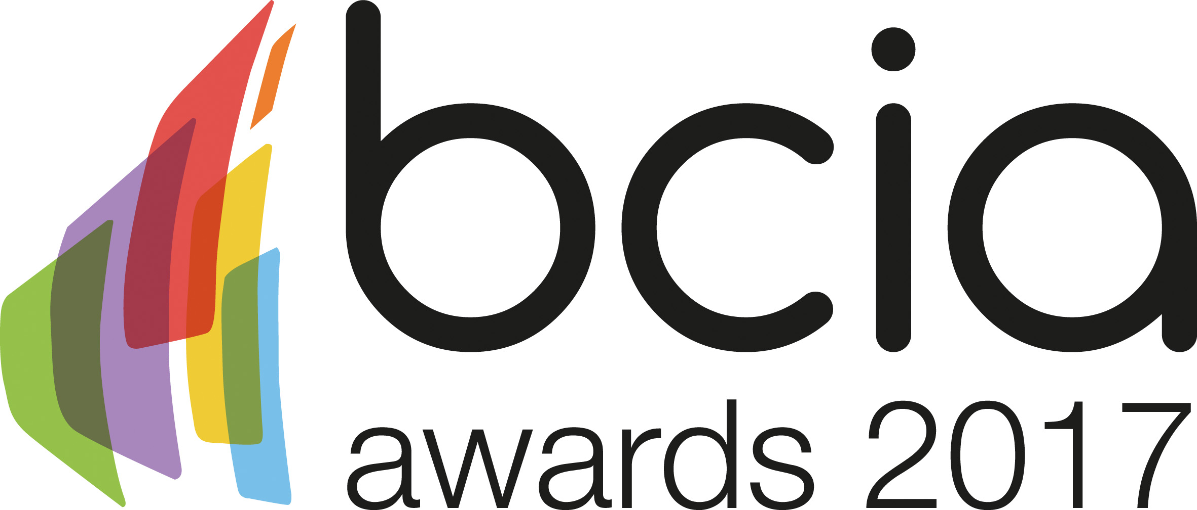

Press Release

3 October 2016

Entries go live for the 2017 BCIA Awards

Entries are now open for the 2017 Building Controls Industry Association (BCIA) Awards which promise to be better than ever before.

The BCIA Awards is the most exclusive event in the building controls calendar. In 2017 this highly anticipated awards ceremony takes place on Thursday 11 May 2017 and will be held at the Hilton Birmingham Metropole.

The perfect venue for this growing event, the Hilton Birmingham Metropole provides a fantastic opportunity for guests to network with key decision makers whilst celebrating the best performers in the building controls industry.

Now in their 11th year, the awards recognise and reward excellence in the building controls industry providing entrants with a fantastic opportunity to showcase their top products and projects from the past 12 months.

There are eight categories which include; Independent Building Controls and BEMS Installer; Best Service and Maintenance Provider; Technical Innovation of the Year - Projects; Technical Innovation of the Year - Products; Energy Management Award; Contribution to Training; Engineer of the Year and Young Engineer of the Year.
Malcolm Anson, President of the BCIA says: “The BCIA Awards are an excellent opportunity for the building controls industry to showcase its achievements. The professional excellence of our industry is something to be proud of and we should celebrate our successes. I would encourage everyone to enter and gain the recognition they deserve.

“We are delighted to welcome on board our gold sponsors; Centraline by Honeywell; Johnson Controls; Modern Building Services; Priva; Siemens Building Technologies; Trend Control Systems and Western Automation. They will play a key role in ensuring that the 2017 event will be bigger than ever before.”

The deadline for entries is the 31 January 2017. To enter simply visit the BCIA website, www.bcia.co.uk, and submit your entries via the online form. Entry to the awards is free and open to BCIA members and non-members.

www.bcia.co.uk

Note to editors
The Building Controls Industry Association (BCIA) represents the UK building controls and BEMS sector. With around 80 members accounting for 70% of the UK controls market, the BCIA is an influential group that promotes better specification, application and use of controls. The BCIA also offers its own training courses and the Building Controls Professional Assessment (BCPA).

For further information about the BCIA please contact Keystone Communications:

Tracey Rushton – Thorpe
Tel: 01733 294 524
Email: tracey@keystonecomms.co.uk

Leanne Elliott
Tel: 01733 294 524
Email: leanne@keystonecomms.co.uk

