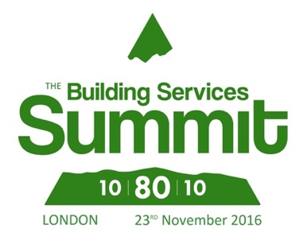
6th October
Press release
For immediate release

Building Services Summit 2016 tackles the big issues for our sector head on.
The Building Services Summit will be asking the hard questions and looking for input from delegates as well as industry experts. This year, it's all about finding solutions to make buildings better - energy efficient; occupant-friendly; and value for money.

The Summit takes place on 23rd November at the British Library and has been organised jointly by the BCIA, BESA and ECA - making this a unique event developed by associations for their members and clients.

Expert speakers from the National Energy Foundation, ARUP, Gratte Brothers, ISS Technical Services as well as Government departments including BEIS, will be sharing their knowledge - but we'll also be asking delegates to share their thoughts too in some highly interactive discussions and debates.

The Summit will be tackling the big issues head on:
* Is the construction process broken?
* What are the barriers to delivering buildings that work?
* Retentions - why are we still living with them?
* What are the alternatives to the current process of construction?
* What works - and can we do more of it?

The Summit includes some great presentations, but these lively discussion panels, moderated by television presenter and journalist Juliet Morris, will allow Summit delegates to share their ideas and views too. Interactive technology will be used on the day to gather thoughts on key questions, creating a very lively event for all.

BCIA President Malcolm Anson says: "This is a great opportunity to be part of a unique event that is seeking to tackle the key issues in our sector. It's also a chance to network with professionals from across the construction and property sector, while sharing ideas for improving how we work together. "

For more information, and to book your place, see www.buildingservicessummit.co.uk

Press contact: Karen Fletcher, karen@bcia.co.uk or call 07921 518 542

