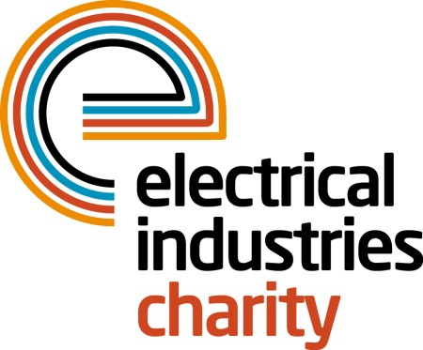
Press Release

18 October 2016

Climb to the top for our Challenge for a Cause

Enthusiastic trekkers are continuing to sign up to climb the tallest free-standing mountain in the world - Mount Kilimanjaro - to raise money for the Hendrie family. Show your support for this incredible cause and get your company in the spotlight by sponsoring flags which will be placed at the top of the peak.

The Electrical Industries Charity is appealing to you to give them a hand up in this challenge of a lifetime by making a donation for a flag. Each flag will bear the sponsor’s logo and will be placed at the top of Mount Kilimanjaro by one of the Challenge for a Cause team.

The Mount Kilimanjaro 10-day challenge is taking place between 03-14 February 2017 and now is your chance to show your support by sponsoring trekkers’ flags for just a £1,000 donation which will ensure that your business logo will be placed at the top of the mountain. A truly unique and fantastic publicity opportunity.

Nine enthusiastic trekkers are joining Tessa Ogle, Managing Director of the Electrical Industries Charity, on this life changing journey. They include Johanne Stimson of Heat Mat; Andrew Dykes of SES Engineering Services Ltd; Mike Smith, of SES Engineering Services Ltd and Senior Vice President of the ECA; Denise Hillier of Spring Electrical Ltd; Mark David Ward of Power 1 Group; Dave Gilbert of SCV Electrical Limited, Dr Diana Macarthur supporting Power 1 Group, Rosemary Phillips of RDM Electrical and Mechanical Services and Joseph Hogg of Edmundson Electrical Ltd.

Senior Estimator of SES Engineering Services Ltd, Andrew Dykes says: “I have taken on the challenge as I know that we all sometimes need help and support through difficult times in our lives. On this occasion, the Hendrie family need the support of others to give hope to the family and create a better and brighter future.”

Christopher Hendrie aged 32 was a well-respected electrician, a loving husband and a father of two who lost his fight to the rare form of Cholangiocarcinoma cancer on 31 October 2014, leaving his wife and three children without a loving husband and a father. If you would like to find out more about the Hendrie family, please visit the charity’s website.

Show your support today by sponsoring one of the flags and help the Hendrie family to rebuild their lives. Or if you would like to share the contribution with a company or individual who is important to you, please invest in a flag for them, and we will climb to the top for you. For further details or sponsorships, contact Tessa Ogle: tessa.ogle@electricalcharity.org

www.electricalcharity.org

Note to editors
The Electrical Industries Charity is the national charity for the electrical, electronics and energy industries. It aims to look after people from these industries whenever they or their families need help with life’s challenges.

The charitable services are available to anyone who currently works or has worked in the very diverse and often converging industries, such as:
- Electrical contracting and facilities management
- Electrical and electronic manufacturing, wholesale, distribution and retail
- Electrical and mechanical engineering
- Lighting industry
- Generation, distribution and supply of electrical power, including nuclear and renewable energy

For further information about the Electrical Industries Charity please contact Keystone Communications:

Tracey Rushton-Thorpe Monika Gaubyte
Tel: 01733 294524 Tel: 01733 294524
Email: tracey@keystonecomms.co.uk Email: monika@keystonecomms.co.uk

