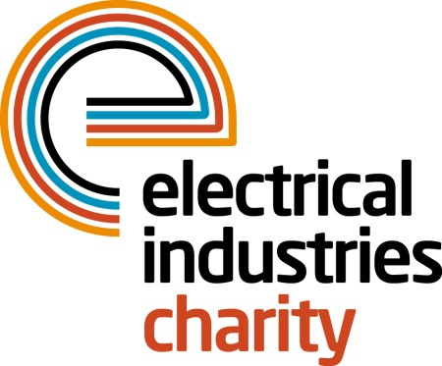
Press Release

31 October 2016

Could you be crowned the dragon boat champion of 2017?

The Electrical Industries Charity is delighted to announce the launch of its 2017 Dragon Boat event which will see industry teams pit their wits against each other to win the coveted Dragon Boat 2017 trophy.

Taking place on Saturday 06 May at Peterborough Rowing Lake, Dragon Boat 2017 promises to be a fun filled event for the whole family with teams of 9 to 11 taking to the water, paddling to the beat of the drum.

An ancient Chinese tradition, dragon boat racing is one of the fastest growing water activities in Britain – and one of the most fun. So if you think you have what it takes to challenge the dragon sign up now.

There are two options for taking part – if you have 9 to 11 willing volunteers then you can sign up for a team boat which costs just £950 of which £300 is donated to the Electrical Industries Charity, with gold, silver and sponsorship packages available including the option to have a dragon boat named after your team or business. Up to ten people from your team will paddle the boat while the drummer beats time at the front and guides you to glory.

But if you don’t have a team of 9 to 11 people then don’t worry because you can reserve individual places for just £90 each – a great opportunity to take part in this fantastic event and the Charity will place you into a team on the day – who knows this may even be a winning combination.

Managing Director, Tessa Ogle says: “Dragon Boat 2017 promises to be a great day out for the industry, families and friends. So whether you are a budding drummer, a willing spectator ready to cheer everyone on or a champion oarsman in the making - you need to be there.

“As well as being great fun, this event will enable the Charity to continue to provide support to those in our industry who need it most. So why not show your support. Someone in our industry will be crowned the dragon boat champion of 2017 - sign up now and it could be you!”

For further information and to book your place, please contact Charlotte Laurent: charlotte.laurent@electricalcharity.org

www.electricalcharity.org

Note to editors
The Electrical Industries Charity is the national charity for the electrical, electronics and energy industries. It aims to look after people from these industries whenever they or their families need help with life’s challenges.

The charitable services are available to anyone who currently works or has worked in the very diverse and often converging industries, such as:
- Electrical contracting and facilities management
- Electrical and electronic manufacturing, wholesale, distribution and retail
- Electrical and mechanical engineering
- Lighting industry
- Generation, distribution and supply of electrical power, including nuclear and renewable energy

For further information about the Electrical Industries Charity please contact Keystone Communications:

Tracey Rushton-Thorpe Monika Gaubyte
Tel: 01733 294524 Tel: 01733 294524
Email: tracey@keystonecomms.co.uk Email: monika@keystonecomms.co.uk

