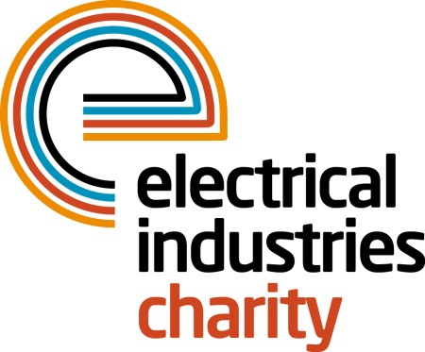
Press Release

28 November 2016

Light your competitive fire at Dragon Boat 2017

The Electrical Industries Charity is calling on all electrical, electronics and energy installers, suppliers, contractors and manufacturers to sign up for the largest electrical sporting event of the year. Light your competitive fire and have a once in a lifetime team-building experience at Dragon Boat 2017.

Dragon Boat 2017 is an adrenaline fuelled competition for teams and individuals of all levels who are ready to battle it out in order to be crowned winners of the Dragon Boat challenge.

The EIC’s Dragon Boat Challenge is taking place on Saturday 06 May at Peterborough Rowing Lake. This fun-filled event promises to be a memorable experience for all the dragon boat crews and their families and friends, with plenty of activities available throughout the day including funfair rides, face-painting, food stalls and a bouncy castle.

Sign up a team of 9 to 11 for just £950, or get an individual place for only £90 each and let the charity place you into a team for this heart-pumping water sports challenge. Or why not make the most out of this thrilling event by choosing gold or silver sponsorship packages with an option to have a dragon boat named after your company or team to maximise your media exposure.

Managing Director, Tessa Ogle says: “Dragon Boat 2017 is a fantastic team-building event that requires no training, just lots of energy and bags of enthusiasm throughout the day. Those who sign up for this experience will be in with a chance of going down in history as the charity’s inaugural winners, setting the precedent for years to come.

“It is said that alone we can do a little, together we can make a difference, therefore make a splash in the upcoming spring by signing up to Dragon Boat 2017 and help us to make a difference to thousands of people’s lives in the next year.”

For further details and to book your place, please contact Charlotte Laurent: charlotte.laurent@electricalcharity.org

www.electricalcharity.org

Note to editors
The Electrical Industries Charity is the national charity for the electrical, electronics and energy industries. It aims to look after people from these industries whenever they or their families need help with life’s challenges.

The charitable services are available to anyone who currently works or has worked in the very diverse and often converging industries, such as:
- Electrical contracting and facilities management
- Electrical and electronic manufacturing, wholesale, distribution and retail
- Electrical and mechanical engineering
- Lighting industry
- Generation, distribution and supply of electrical power, including nuclear and renewable energy

For further information about the Electrical Industries Charity please contact Keystone Communications:

Tracey Rushton-Thorpe Monika Gaubyte
Tel: 01733 294524 Tel: 01733 294524
Email: tracey@keystonecomms.co.uk Email: monika@keystonecomms.co.uk

