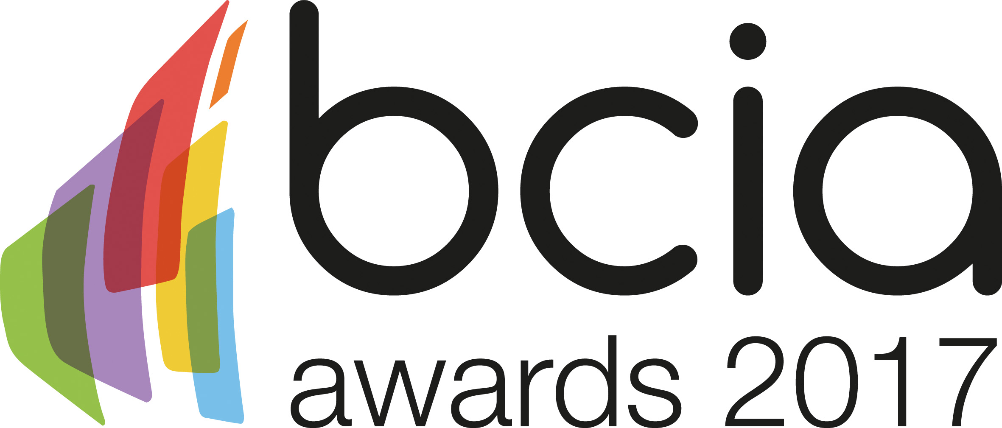

Press Release

7 December 2016

Gain recognition at the leading industry awards

The BCIA calls for the entire controls industry to submit their entries for the 2017 BCIA Awards, to gain the recognition they deserve and celebrate the achievements of their industry.

The 2016 awards saw a record number of entries showing the controls industry is achieving great things and has a lot to be proud of. For example, InTandem Systems, winner of Independent Building Controls and BEMS Installer of the Year demonstrated outstanding customer service, developing close working relationships with all stakeholders during and after installation and exceeding customer expectations, to ensure the BMS solution met everyone’s needs.

In 2017 there is an award category for everyone to enter, including: Independent Building Controls and BEMS Installer; Best Service and Maintenance Provider; Technical Innovation of the Year - Projects; Technical Innovation of the Year - Products; Energy Management Award; Contribution to Training; Engineer of the Year and Young Engineer of the Year.
Casey Wells, of sponsor Trend Control Systems comments: “I was really impressed by the calibre of nominees in 2016, it is an indicator of the professional excellence that exists in our industry which truly deserves recognition. With so much happening in the building controls sector at the moment, it would be great to see even more entries for the 2017 BCIA awards.

“The independent judges will be looking for individuals to showcase their projects and achievements from the past year, as well as the new technology and innovation the controls industry has to offer.”

The deadline for entries is 31 January 2017. To enter simply visit the BCIA website, www.bcia.co.uk, and submit your entries via the online form. Entry to the awards is free and open to BCIA members and non-members.

The coveted awards will be presented at an exclusive awards ceremony which will take place on Thursday 11 May 2017 at the Hilton Birmingham Metropole.

www.bcia.co.uk

Note to editors
The Building Controls Industry Association (BCIA) represents the UK building controls and BEMS sector. With around 80 members accounting for 70% of the UK controls market, the BCIA is an influential group that promotes better specification, application and use of controls. The BCIA also offers its own training courses and the Building Controls Professional Assessment (BCPA).

For further information about the BCIA please contact Keystone Communications:

Tracey Rushton – Thorpe
Tel: 01733 294 524
Email: tracey@keystonecomms.co.uk

Leanne Elliott
Tel: 01733 294 524
Email: leanne@keystonecomms.co.uk

