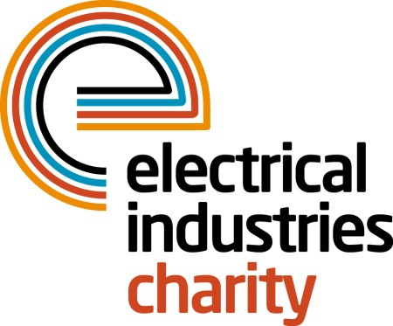

**Press Release**

**12 December 2016**

**Are you ready for the biggest electrical challenge in 2017?**

The Electrical Industries Charity is delighted to announce the Electrical Contractors’ Association (ECA) and City Electrical Factors (CEF) as headline sponsors for the biggest sporting event of the year - Dragon Boat 2017.

Dragon Boat 2017 promises to be the most exciting sporting event in the electrical calendar bringing the entire industry together for a fun-filled day out.

The charity is offering a range of packages. Teams of 9 to 11 people can secure a standard place for only £950. Don’t have a team? You can secure your individual entry for £90 and let the charity place you in the team.

The charity’s leading sporting event is also offering companies the opportunity to maximise their media exposure with gold and silver packages.

Gain the most publicity with a gold sponsorship package for £1,800, which allows you to enjoy the benefits of a team entry of 9 to 11 people and have a dragon boat named after your business or team. Alternatively, you can choose a silver package for £1,200 and gain additional benefits and excellent media exposure.

Managing Director, Tessa Ogle says: “Dragon Boat 2017 is one of the most exciting ways you can choose to spend your summer away from the office with your family, friends and colleagues.

“Through our range of sponsorship packages, companies will have an opportunity to increase their profile and showcase their business while building relationships in a fun and relaxed environment.”

Dragon Boat 2017 is taking place on Saturday 06 May 2017 at the stunning riverside setting- Peterborough Rowing Lake.

Now is your chance to unleash your inner dragon and help the charity to raise much –needed funds for those who need your help the most. For further details or to book your place, please contact Charlotte Laurent: [charlotte.laurent@electricalcharity.org](mailto:charlotte.laurent@electricalcharity.org)

[www.electricalcharity.org](http://www.electricalcharity.org)

**Note to editors**

The Electrical Industries Charity is the national charity for the electrical, electronics and energy industries. It aims to look after people from these industries whenever they or their families need help with life’s challenges.

The charitable services are available to anyone who currently works or has worked in the very diverse and often converging industries, such as:

* Electrical contracting and facilities management
* Electrical and electronic manufacturing, wholesale, distribution and retail
* Electrical and mechanical engineering
* Lighting industry
* Generation, distribution and supply of electrical power, including nuclear and renewable energy

For further information about the Electrical Industries Charity please contact Keystone Communications:

Tracey Rushton-Thorpe Monika Gaubyte

Tel: 01733 294524 Tel: 01733 294524

Email: [tracey@keystonecomms.co.uk](mailto:tracey@keystonecomms.co.uk) Email: monika@keystonecomms.co.uk