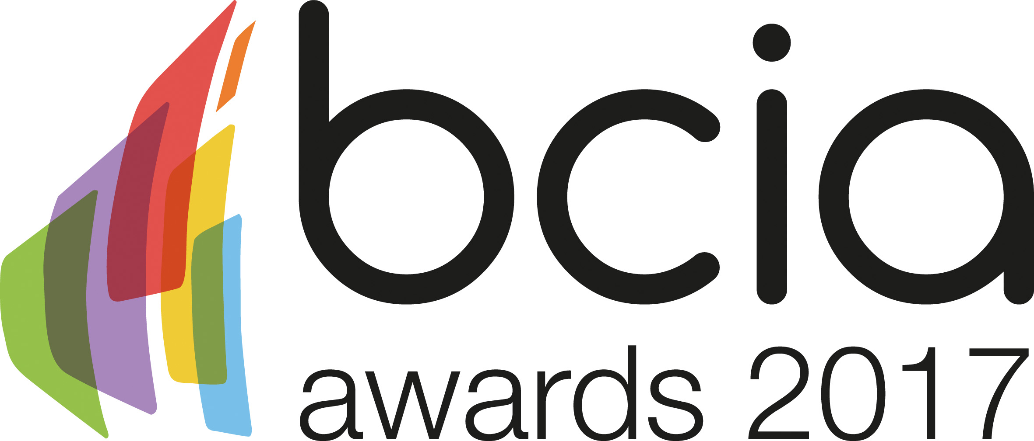

Press Release

16 January 2017

Building controls-help us show their true value

Building controls are responsible for the long term performance of a building and ultimately achieving energy efficiency - something which the industry should celebrate and be proud of.

Why not be part of that celebration by entering the 2017 BCIA Awards. The deadline for entries is Tuesday 31 January 2017. To enter simply visit the BCIA website, www.bcia.co.uk, and submit your entries via the online form. Entry to the awards is free and open to BCIA members and non-members.

Malcolm Anson, President of the BCIA, said: “Building controls offer numerous benefits, though often outside of the industry they are often misunderstood and underappreciated. This is why the awards are so important. We need to come together as an industry to show the true value of controls and how they are crucial in bringing buildings to life.”

To book your places at the prestigious gala dinner and awards ceremony taking place at the Hilton Birmingham Metropole on Thursday 11 May 2017, visit the BCIA website, www.bcia.co.uk and complete the booking form. Tables of ten are available for only £1,000.00 plus VAT, and individual places for £120.00 plus VAT.

www.bcia.co.uk

Note to editors
The Building Controls Industry Association (BCIA) represents the UK building controls and BEMS sector. With around 80 members accounting for 70% of the UK controls market, the BCIA is an influential group that promotes better specification, application and use of controls. The BCIA also offers its own training courses and the Building Controls Professional Assessment (BCPA).

For further information about the BCIA please contact Keystone Communications:

Tracey Rushton – Thorpe
Tel: 01733 294 524
Email: tracey@keystonecomms.co.uk

Leanne Elliott
Tel: 01733 294 524
Email: leanne@keystonecomms.co.uk

